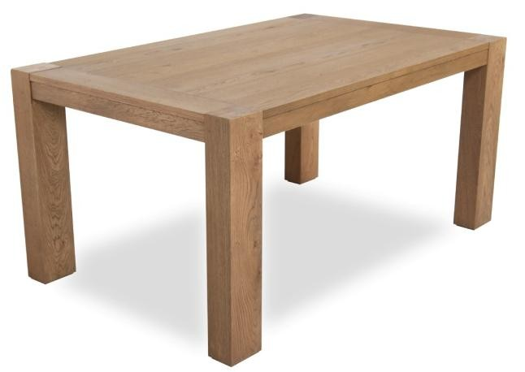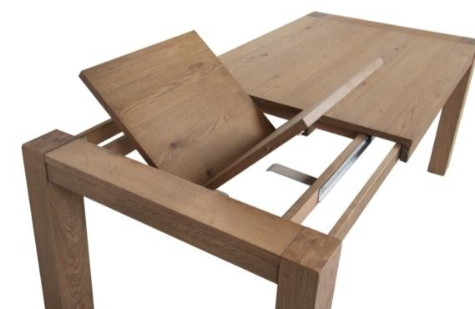

**Tavolo mod. "SALISBURGO" (Fisso / 1 Allunga da 60 cm.)**

TOP TABLE THICKNESS 2,6/2,7 cm.;

**LEG DIMENSIONS 10x14 cm.**

|  |  |  |  |  |  |
| --- | --- | --- | --- | --- | --- |
| **Tavolo mod.**  **"SALISBURGO"** |  | **WILD OAK MASIV** | **WILD OAK MASIV**  **BRUSHED** | **OAK MASIV** | **OAK MASIV**  **BRUSHED.** |
| **TF / 90 x 140** | *€.* | **416** | **424** | **464** | **472** |
| **T-1A / 90 x 140+60** | *€.* | **585** | **595** | **668** | **678** |
| **TF / 90 x 160** | *€.* | **439** | **448** | **492** | **501** |
| **T-1A / 90 x 160+60** | *€.* | **608** | **61** | **695** | **707** |
| **TF / 90 x 180** | *€.* | **462** | **472** | **519** | **530** |
| **T-1A / 90 x 180+60** | *€.* | **638** | **651** | **731** | **745** |
| **TF / 90 x 200** | *€.* | **474** | **485** | **535** | **546** |
| **T-1A / 90 x 200+60** | *€.* | **643** | **658** | **738** | **753** |
| **TF / 100 x 200** | *€.* | **488** | **500** | **551** | **563** |
| **T-1A / 100 x 200+60** | *€.* | **656** | **672** | **753** | **769** |
| **DIFFERENZE PREZZI TAVOLI PER GAMBE A RICHIESTA** | | | | | |

*A PREVENTIVO: TAVOLI A MISURA*

**TF** : FIX TABLE;

**T-1A** : EXTENDABLE TABLE WITH 1 EXTENSION OF60 cm.;

***2***