**[](https://www.google.ro/imgres?imgurl=https://t4.ftcdn.net/jpg/00/42/74/35/240_F_42743502_wUKCvmhABl1C8W2L424PAYzwBlSVT61G.jpg&imgrefurl=https://eu.fotolia.com/tag/%22made%20in%20romania%22&docid=OwrJuhO7L3zPdM&tbnid=dV9hbdzWtKZ9QM:&vet=12ahUKEwj4heSypIraAhVRY1AKHfOpAPY4ZBAzKAswC3oECAAQDA..i&w=278&h=240&bih=983&biw=2021&q=fabricat%20in%20romania&ved=2ahUKEwj4heSypIraAhVRY1AKHfOpAPY4ZBAzKAswC3oECAAQDA&iact=mrc&uact=8)**

**PLASA CRITEX PROTECT**

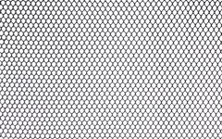 **Este produsa in Romania de catre compania noastra CRILELMAR SRL si utilizeaza materii prime si aditivi de la cei mai reputati producatori .**

**Caracteristici:**

* -**garantie 5 ani**
* **-culoari disponibile :verde tuborg ,portocaliu , verde deschis ; la comanda se pot realiza si alte culori .**
* **-material polietilena (PE) de inalta densitate aditivata UV**
* **-durata de viata indelungata**

|  |  |  |  |  |  |  |
| --- | --- | --- | --- | --- | --- | --- |
| **CALITATE SUPERIOARA** | **PROTECTIE UV** | **RECICLABIL** | **PROTECTIE PASARI** | **TEZISTENTA TRACTIUNE** | **PROTECTIE LEGUME** | **IMPREJMUIRE PASARI** |
| quality%20clipart | https://thumbs.dreamstime.com/z/cute-vector-cartoon-summer-sun-icon-yellow-symbol-sunglasses-isolated-white-background-illustration-design-happy-sunny-69375819.jpg | Reciclare, Simbol, Pictograma, Mediu, Conservarea | [Imagini pentru PICTOGRAMA PASARI](https://www.google.ro/imgres?imgurl=https://i.pinimg.com/originals/8a/9d/26/8a9d2653115612c67332814544181591.gif&imgrefurl=https://ro.pinterest.com/pin/560627853595409373/&docid=sdRnZYynCvpR7M&tbnid=rYndiqCzX2mO2M:&vet=12ahUKEwihg63P7ovaAhXHJ1AKHQI6C_I4ZBAzKF0wXXoECAAQXg..i&w=500&h=500&bih=785&biw=2021&q=PICTOGRAMA%20PASARI&ved=2ahUKEwihg63P7ovaAhXHJ1AKHQI6C_I4ZBAzKF0wXXoECAAQXg&iact=mrc&uact=8) | Estensibile | C:\Users\adriana\Desktop\stockfresh_id1298547_1205bb.jpg | https://images.emojiterra.com/google/android-oreo/512px/1f983.png |

**Plasa protectie si imprejmuire CRITEX PROTECT este confectionata din polietilena aditivata , usoara , rezistenta la intemperii si raze solare si are o foarte buna rezistenta la tractiune si presiune . Plasa prezinta avantajul ca nu rugineste , nu se decoloreaza, se monteaza si se muta usor** .

* **imprejmuiri ale razelor de lucru ale santierelor , imprejmuire pasari**
* **protectie impotriva pasarilor, protectia pomilor , protectie antigrindina**
* **protectia jgheaburilor impotriva cuiburilor de pasari, impotriva depunerii de frunze permitand curatare usoara a acestora, asigura drenarea jgheaburilor.**

|  |  |
| --- | --- |
| **Dimensiune ochi**: **8mmX16mm**  **Dimensiuni rola: 1.2mx25** **ml** | **Dimensiune ochi**: **10mmx20mm**  **Dimensiuni rola: 2mx25** **ml** |

**protectie impotriva pasarilor**

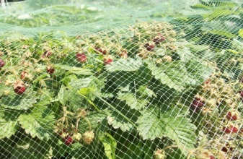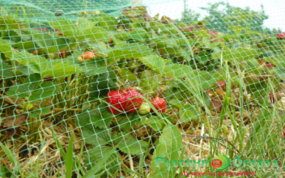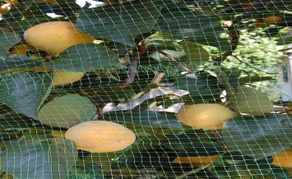[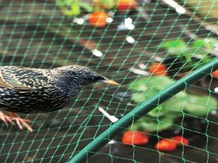](https://www.folie-solar.ro/Media/Default/Thumbs/0000/0000842-plasa-contra-pasari.jpg) **protectia pomilor**

[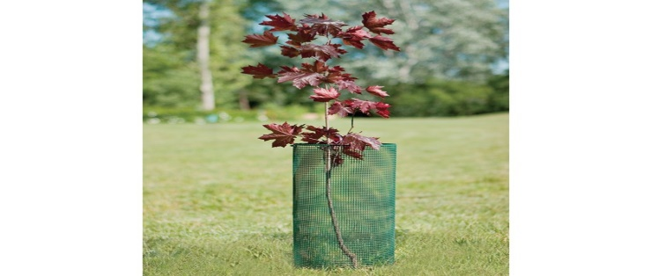](https://www.google.ro/url?sa=i&rct=j&q=&esrc=s&source=images&cd=&ved=2ahUKEwj99a-V7P_ZAhWMaVAKHUy5CgAQjRx6BAgAEAU&url=http://www.archiproducts.com/en/products/tenax/plastic-net-for-flowers-and-climbing-plants-support-corolla_178219&psig=AOvVaw1wFD0nq3q_pmOG9vVXPBs-&ust=1521805149282354)[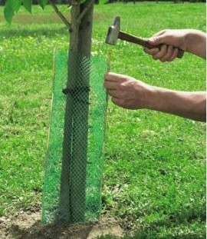](http://cdn2.shopmania.biz/files/s11/653663479/p/l/9/plasa-protectie-pomi-diametru-fi100~29.jpg)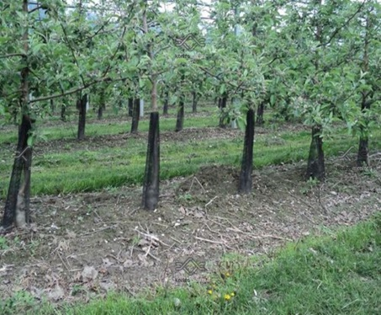**imprejmuire pasari delimitare zone de lucru(santier)**

[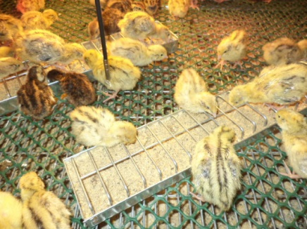](https://www.google.ro/url?sa=i&rct=j&q=&esrc=s&source=images&cd=&cad=rja&uact=8&ved=2ahUKEwj5loW67v_ZAhXSZ1AKHT_1DKwQjRx6BAgAEAU&url=https://rozaliafortis.wordpress.com/2013/03/29/plasa-din-plastic/&psig=AOvVaw3y21ksCf8M-R1DF9jT6LvB&ust=1521805776780974)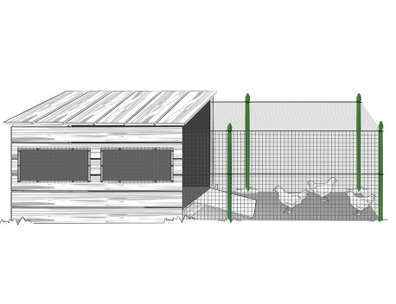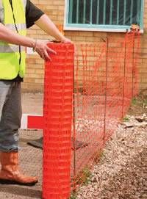

**protectia jgheaburilor**

