OPTIMEDIA OFERĂ O GAMĂ DIVERSĂ DE MODELE UŞI

Pentru comenzi vă rugăm să ne comunicați codul modelului dorit, afișat deasupra fiecărei imagini.

imagini.

**UȘA 01**[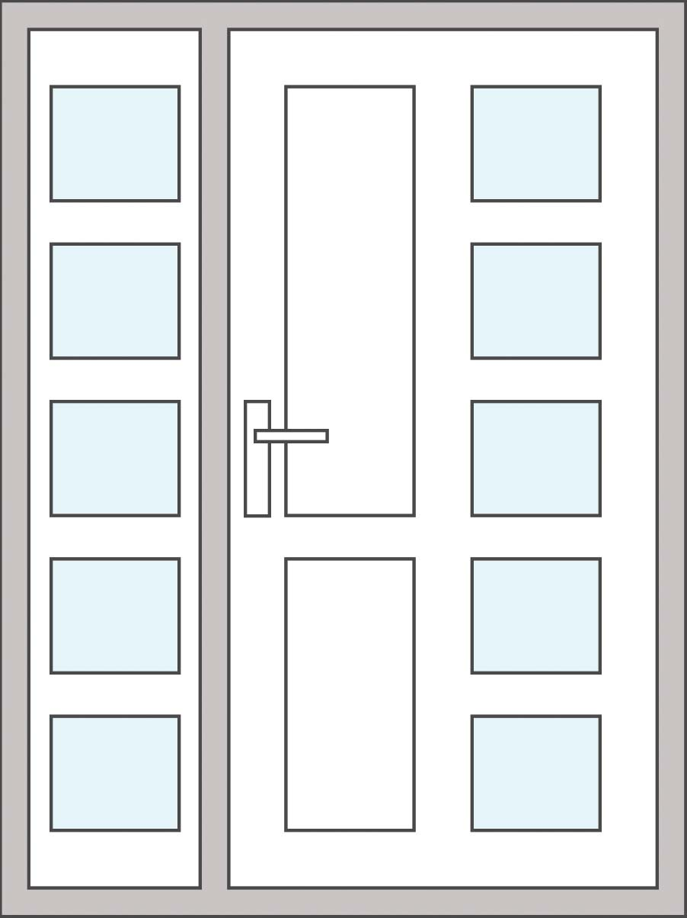](http://www.optimedia.com.ro/wp-content/uploads/2014/11/32.jpg)

**UȘA 02**[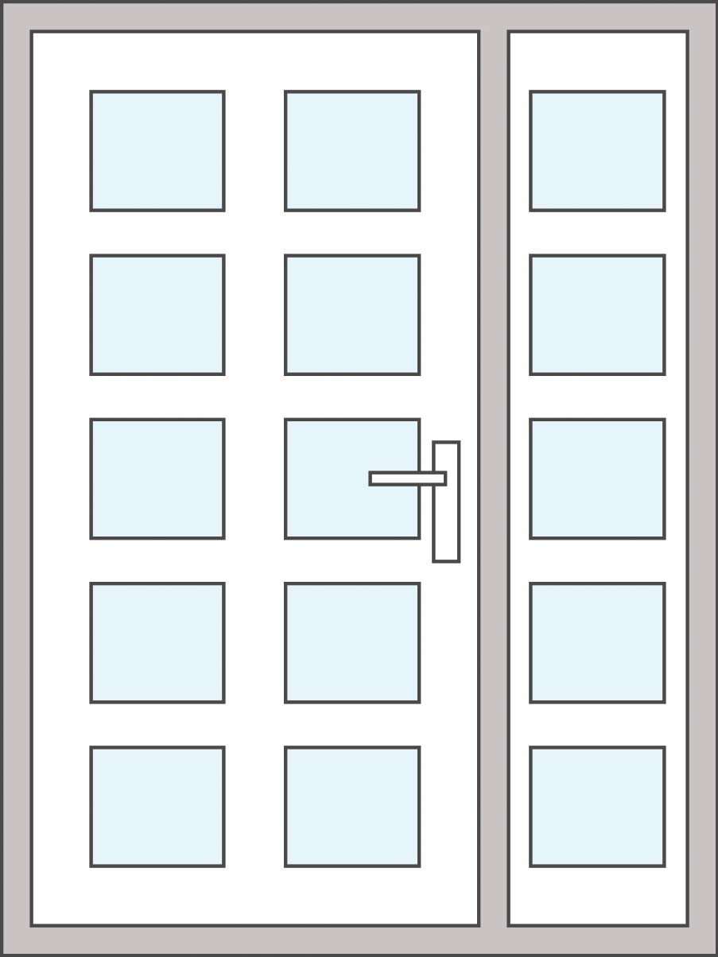](http://www.optimedia.com.ro/wp-content/uploads/2014/11/23.jpg)

**UȘA 03**[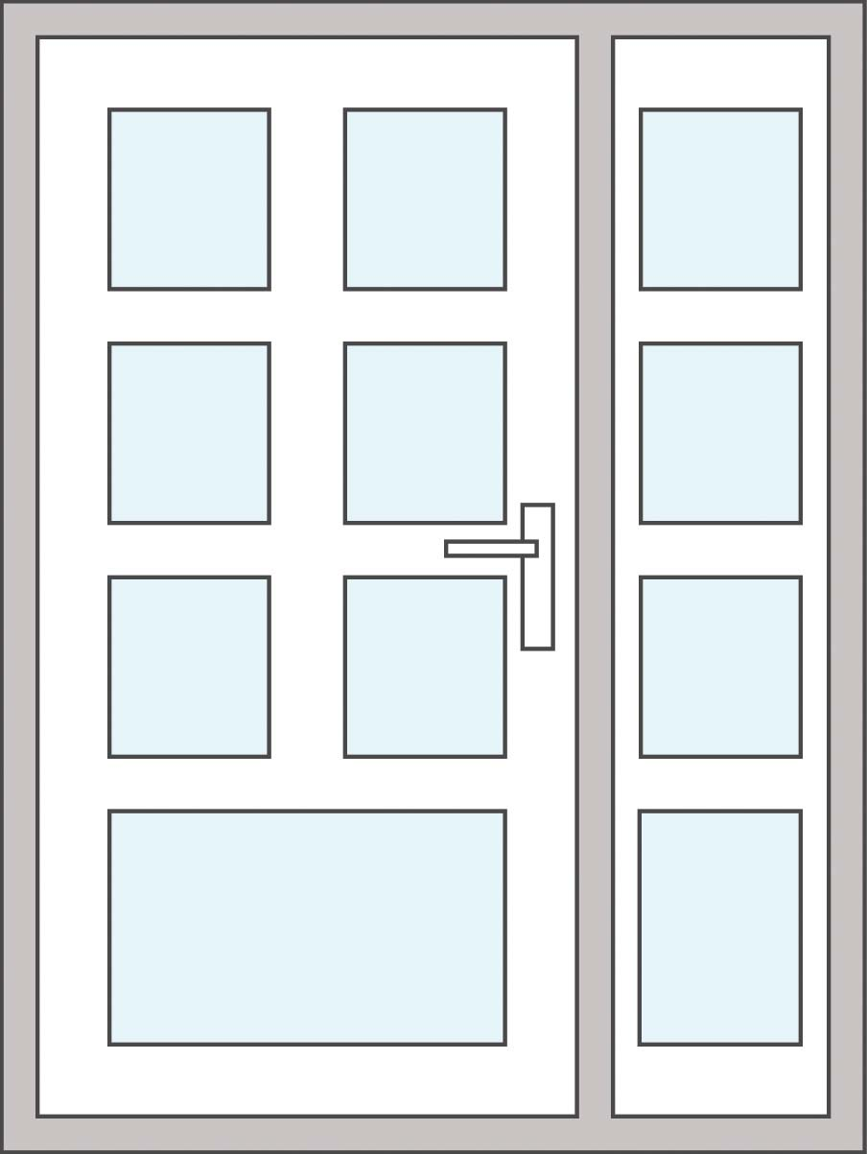](http://www.optimedia.com.ro/wp-content/uploads/2014/11/24.jpg)

**UȘA 04**[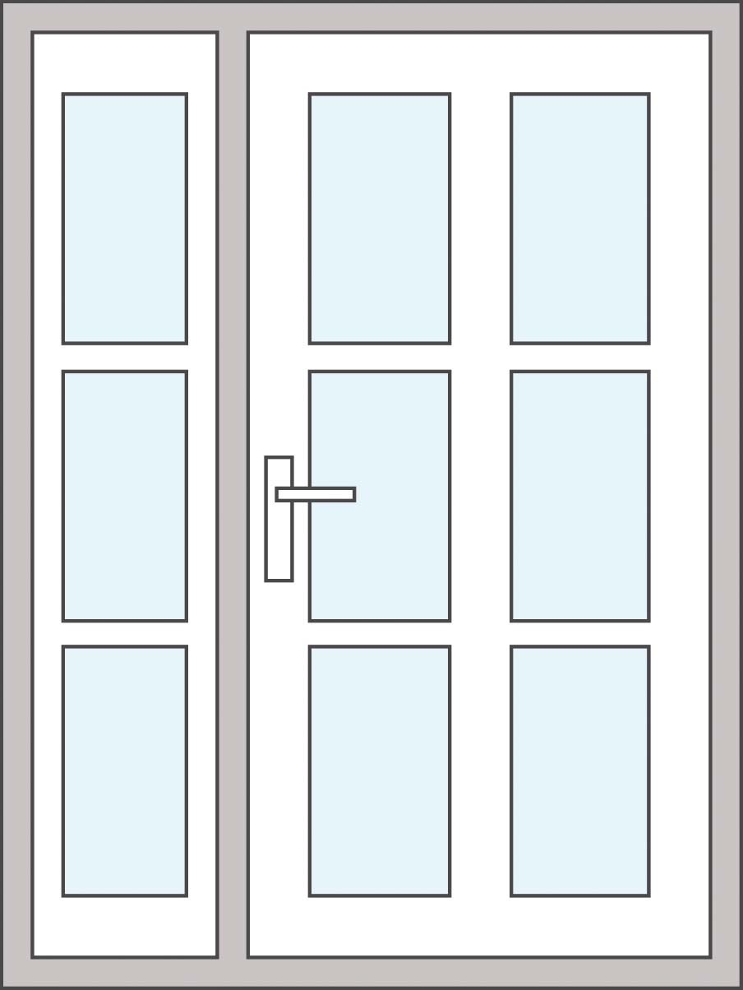](http://www.optimedia.com.ro/wp-content/uploads/2014/11/36.jpg)

**UȘA 05**

[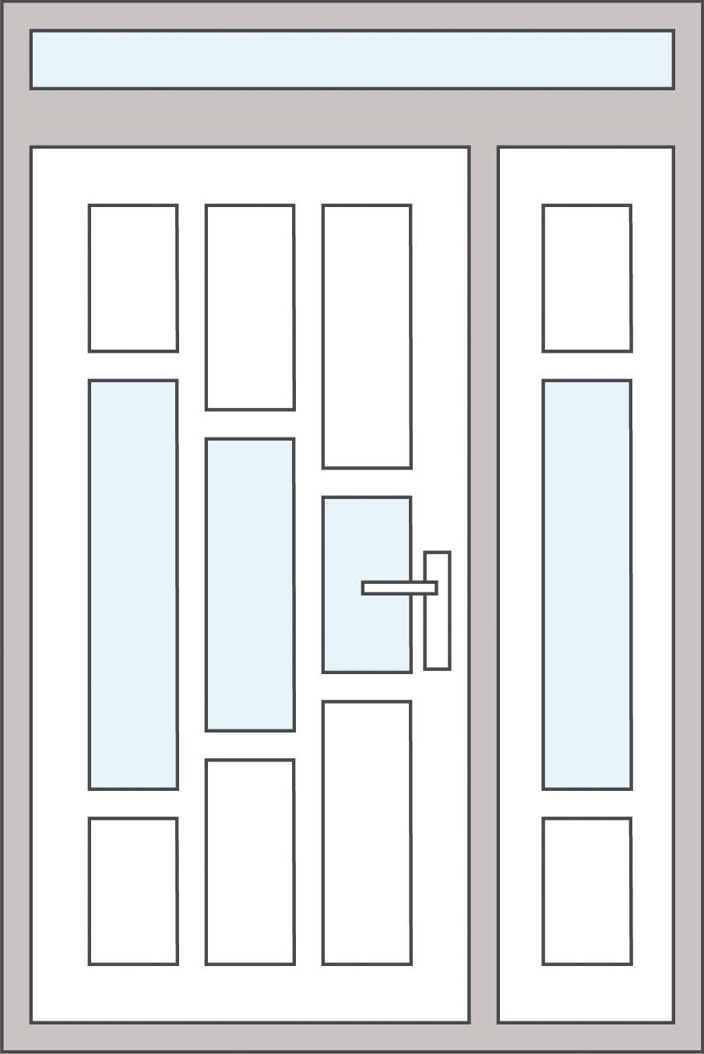](http://www.optimedia.com.ro/wp-content/uploads/2014/11/25.jpg)

**UȘA 06**

[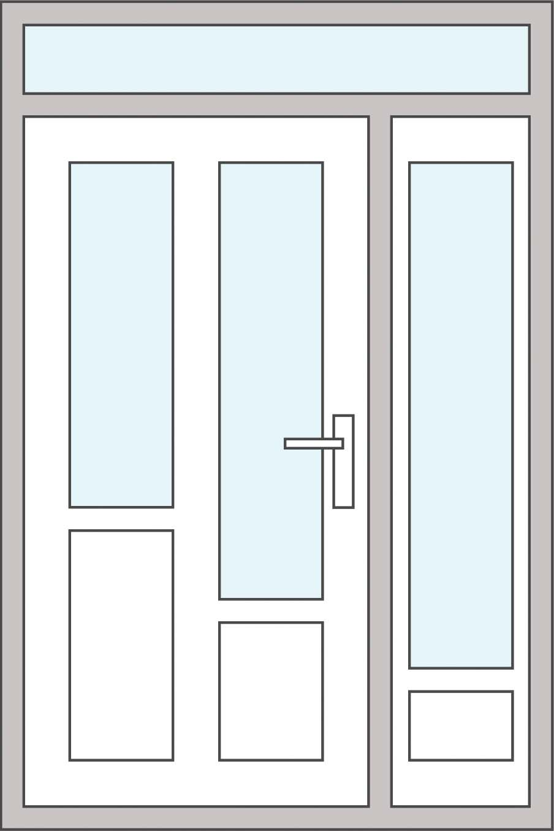](http://www.optimedia.com.ro/wp-content/uploads/2014/11/27.jpg)

**UȘA 07**

[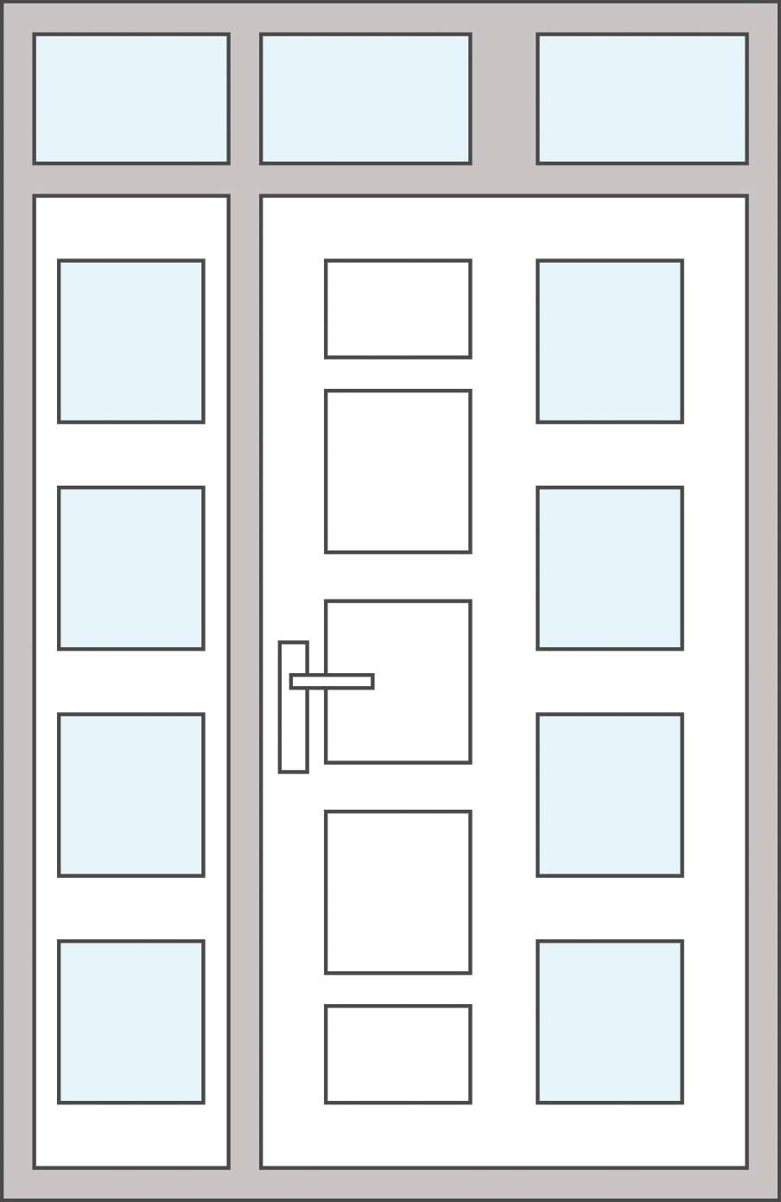](http://www.optimedia.com.ro/wp-content/uploads/2014/11/34.jpg)

**UȘA 08**

[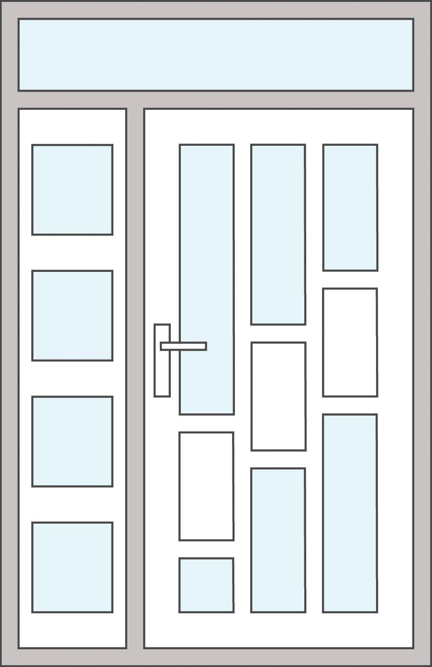](http://www.optimedia.com.ro/wp-content/uploads/2014/11/37.jpg)

**UȘA 09**

[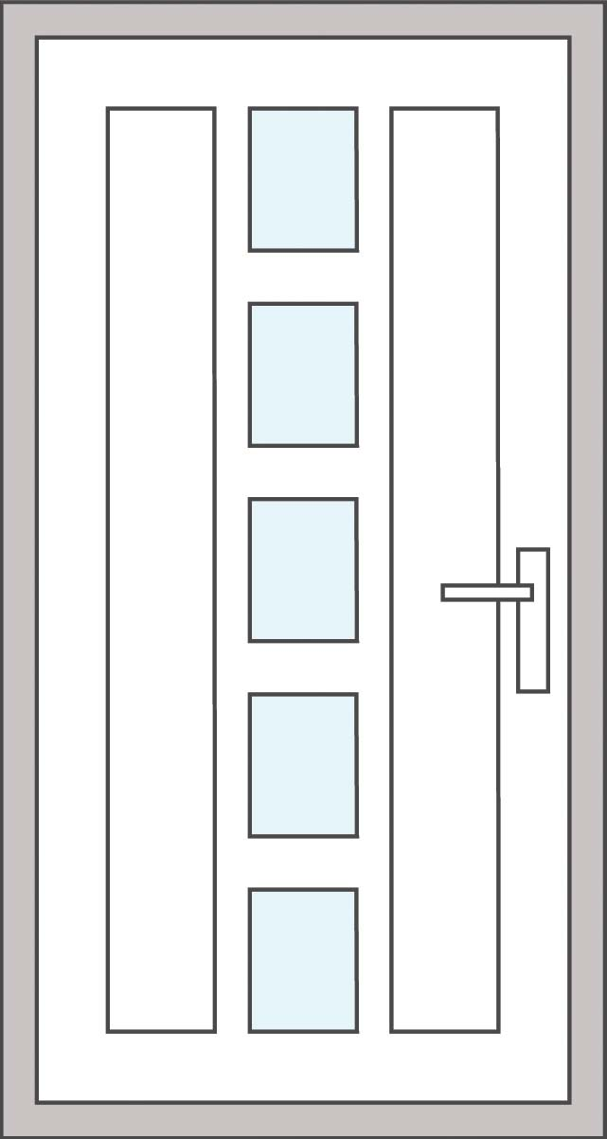](http://www.optimedia.com.ro/wp-content/uploads/2014/11/13.jpg)

**UȘA 10**

[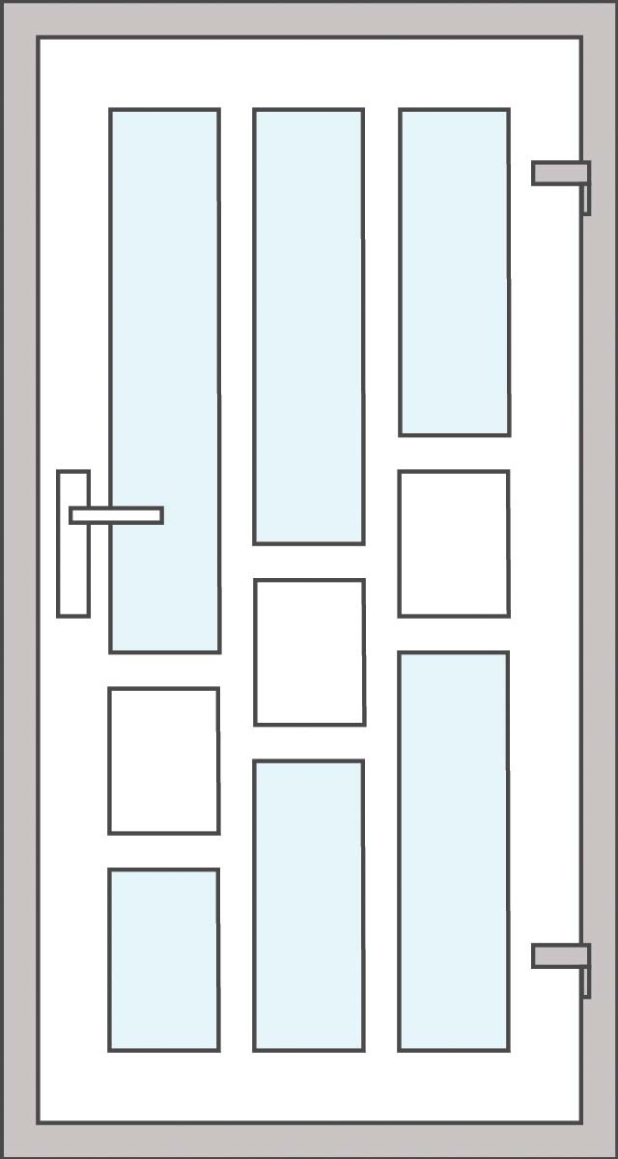](http://www.optimedia.com.ro/wp-content/uploads/2014/11/20.jpg)

**UȘA 11**

[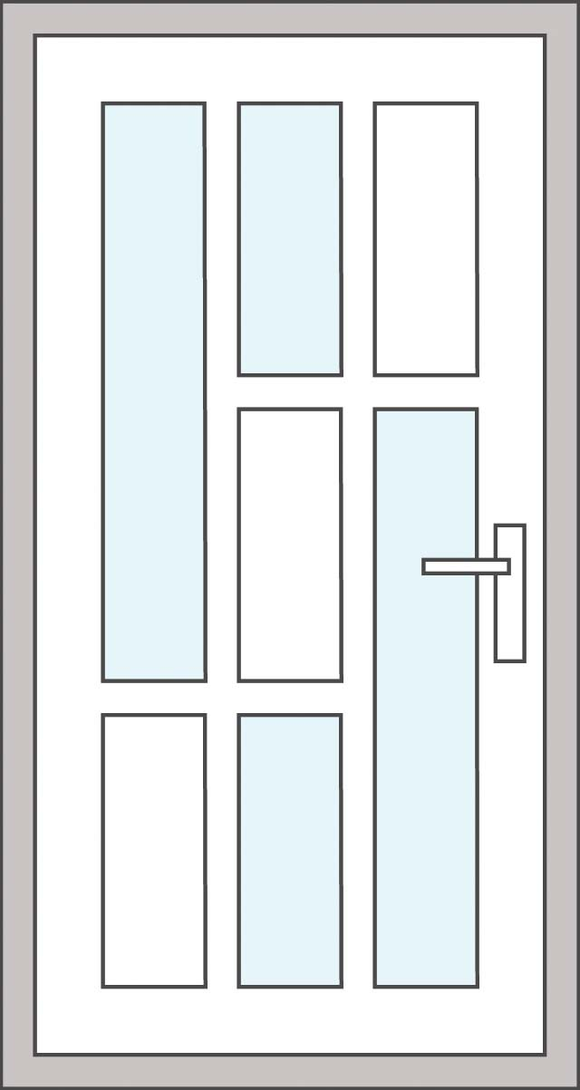](http://www.optimedia.com.ro/wp-content/uploads/2014/11/12.jpg)

**UȘA 12**

[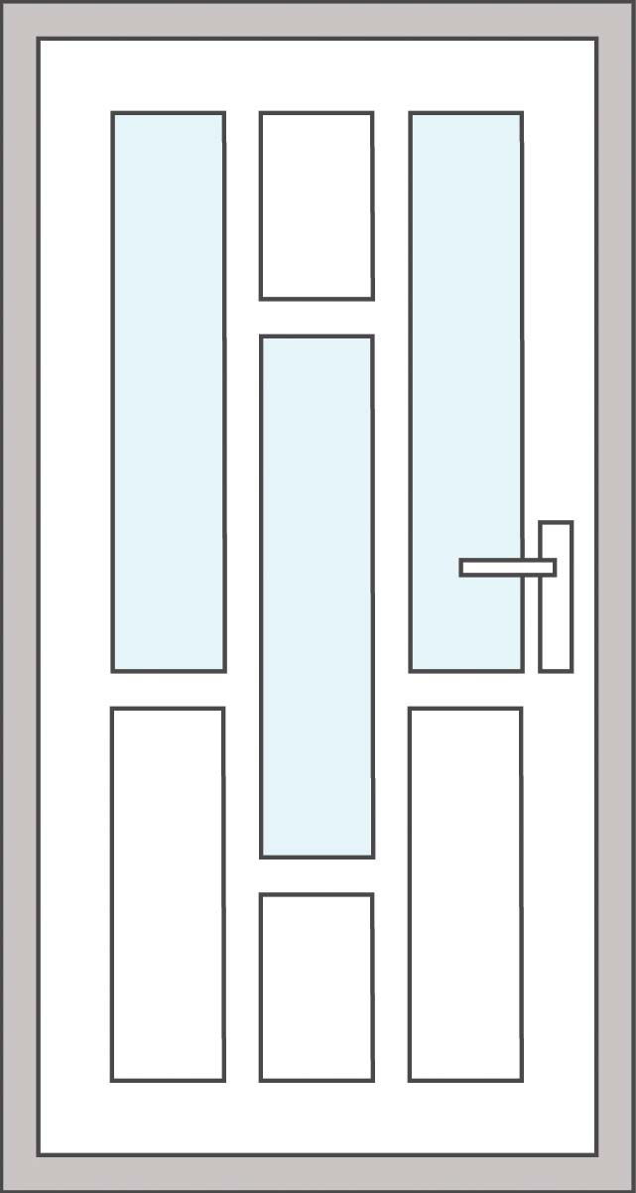](http://www.optimedia.com.ro/wp-content/uploads/2014/11/19.jpg)

**UȘA 13**

[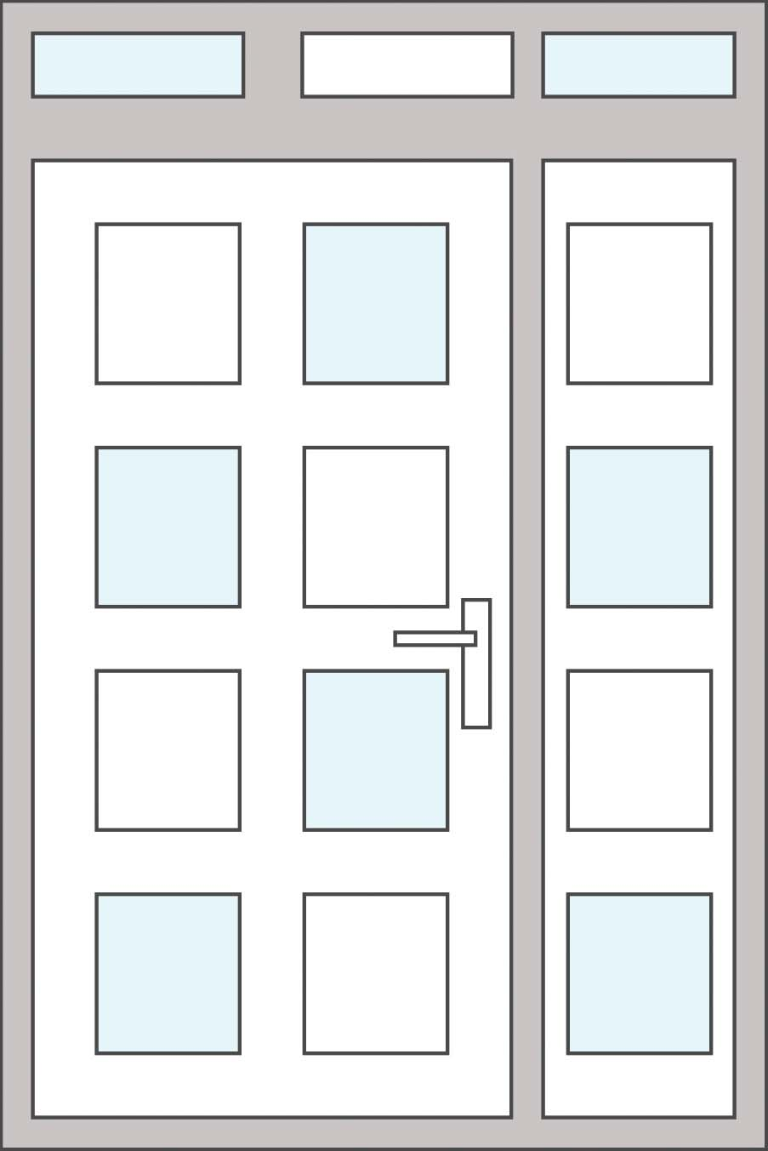](http://www.optimedia.com.ro/wp-content/uploads/2014/11/26.jpg)

**UȘA 14**

[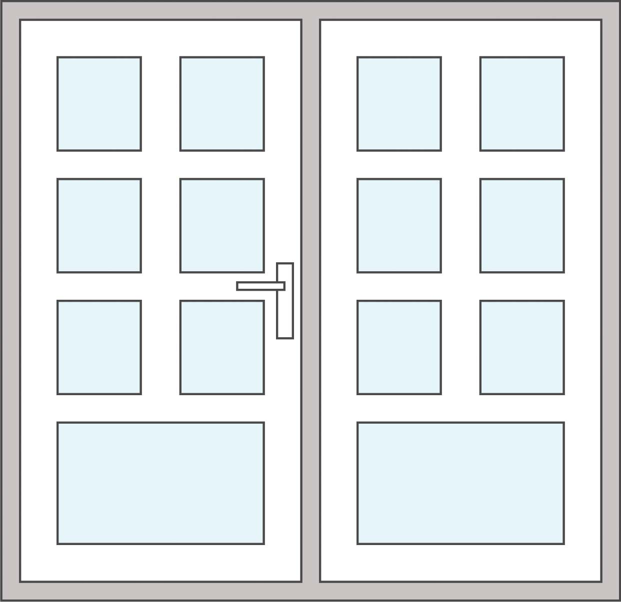](http://www.optimedia.com.ro/wp-content/uploads/2014/11/44.jpg)

**UȘA 15**

[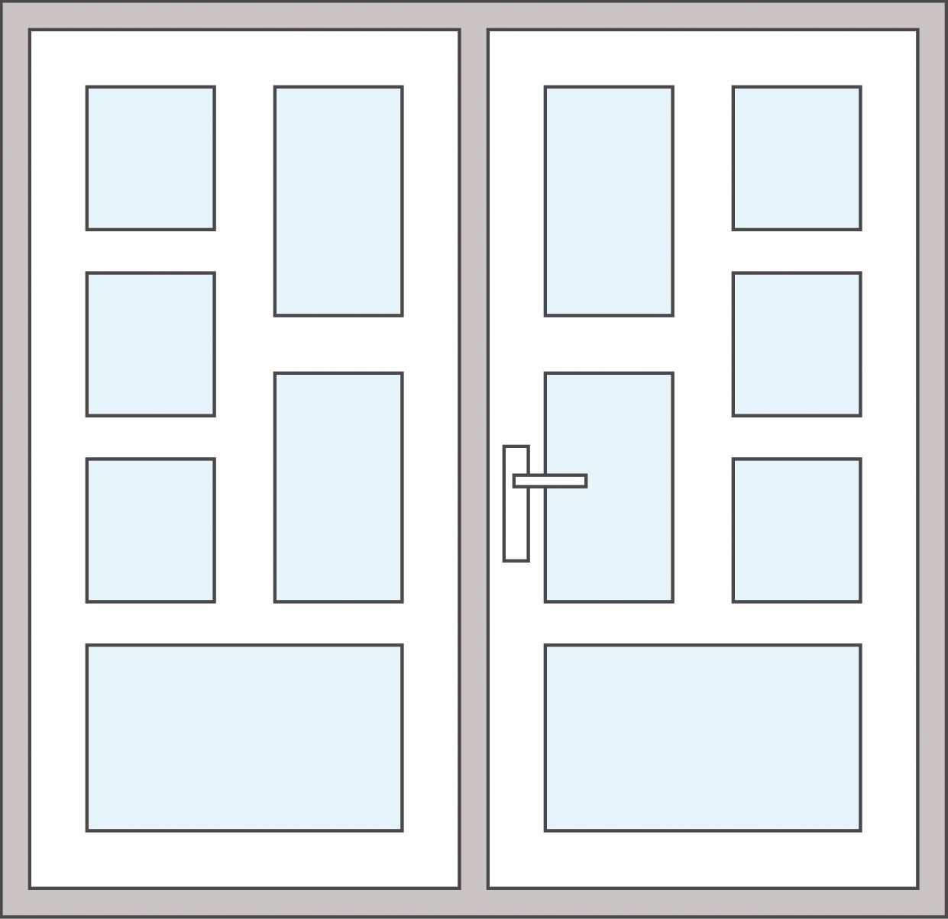](http://www.optimedia.com.ro/wp-content/uploads/2014/11/45.jpg)

**UȘA 16**

[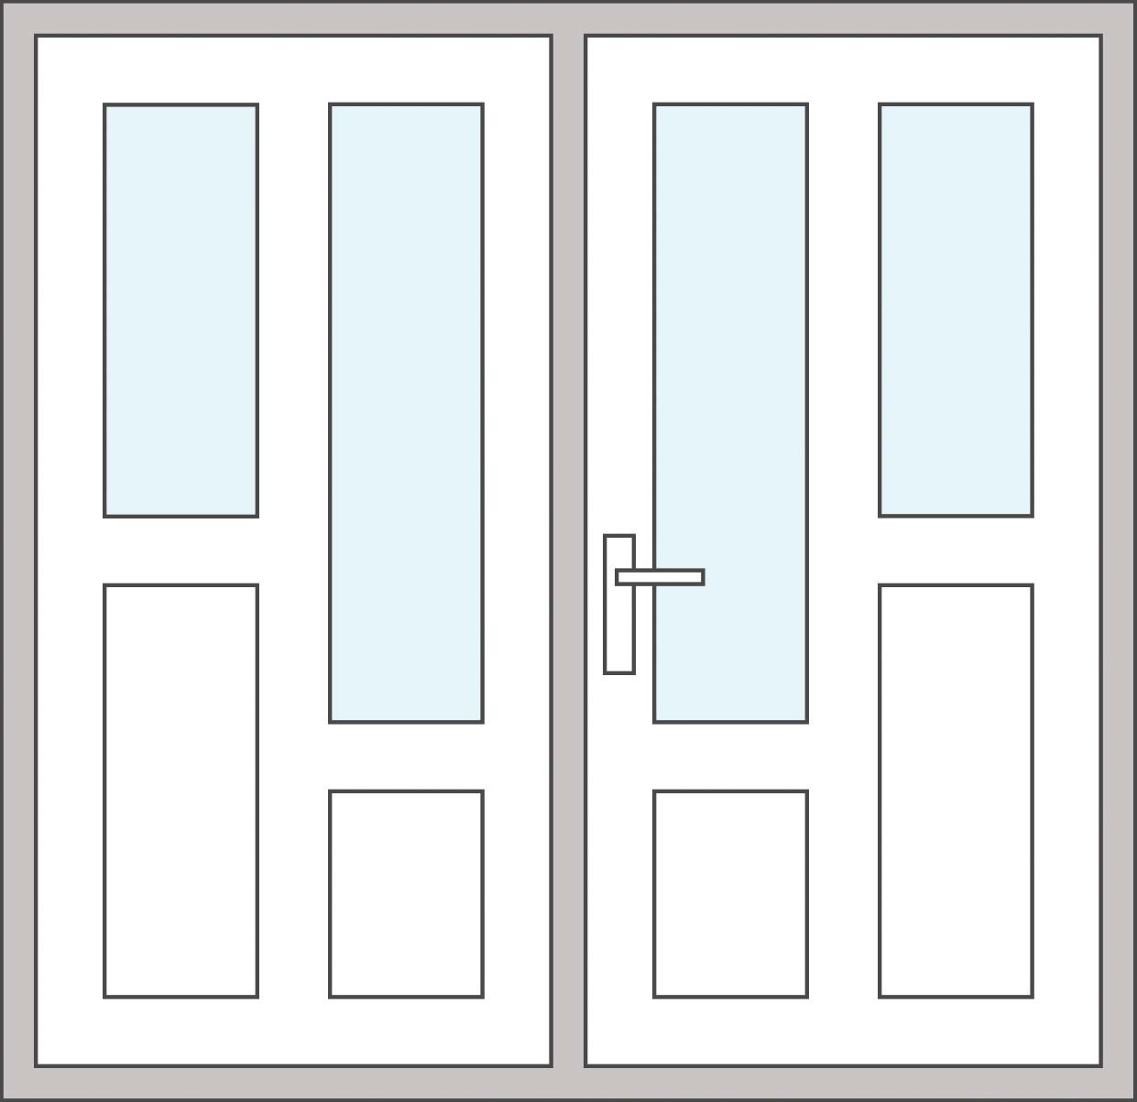](http://www.optimedia.com.ro/wp-content/uploads/2014/11/46.jpg)

**UȘA 17**

[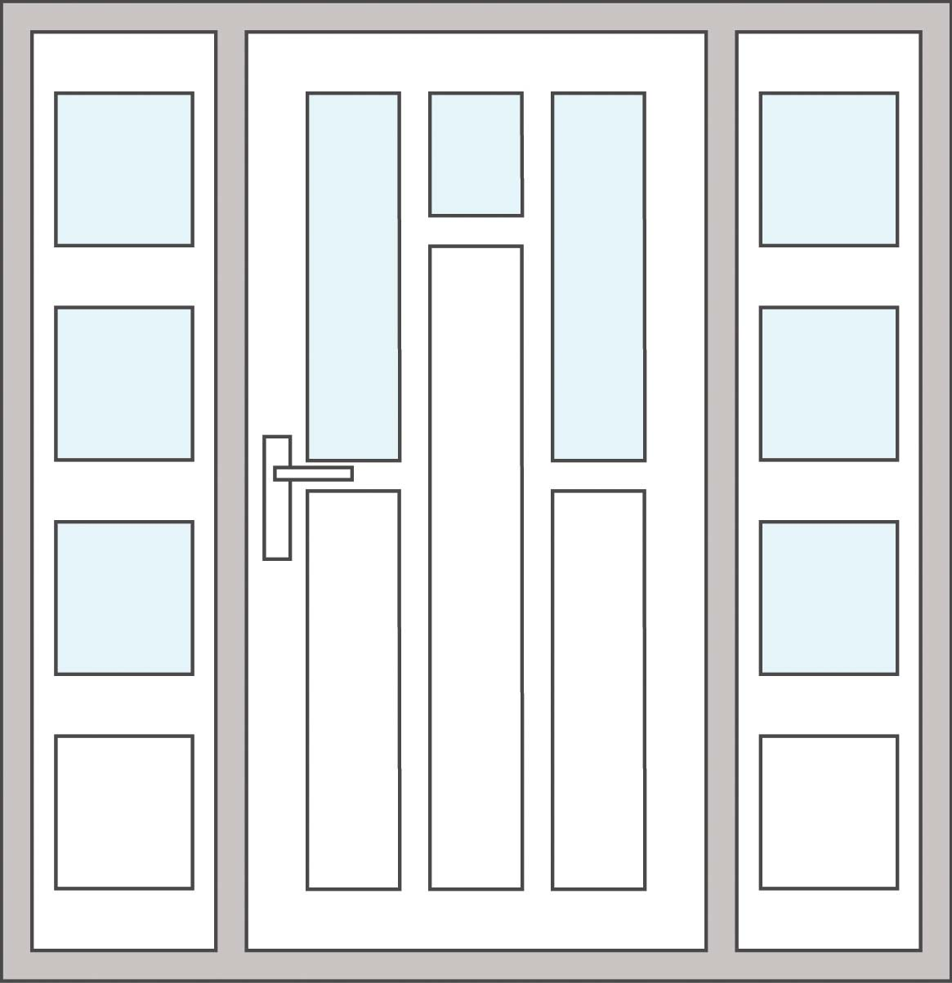](http://www.optimedia.com.ro/wp-content/uploads/2014/11/43.jpg)

**UȘA 18**

[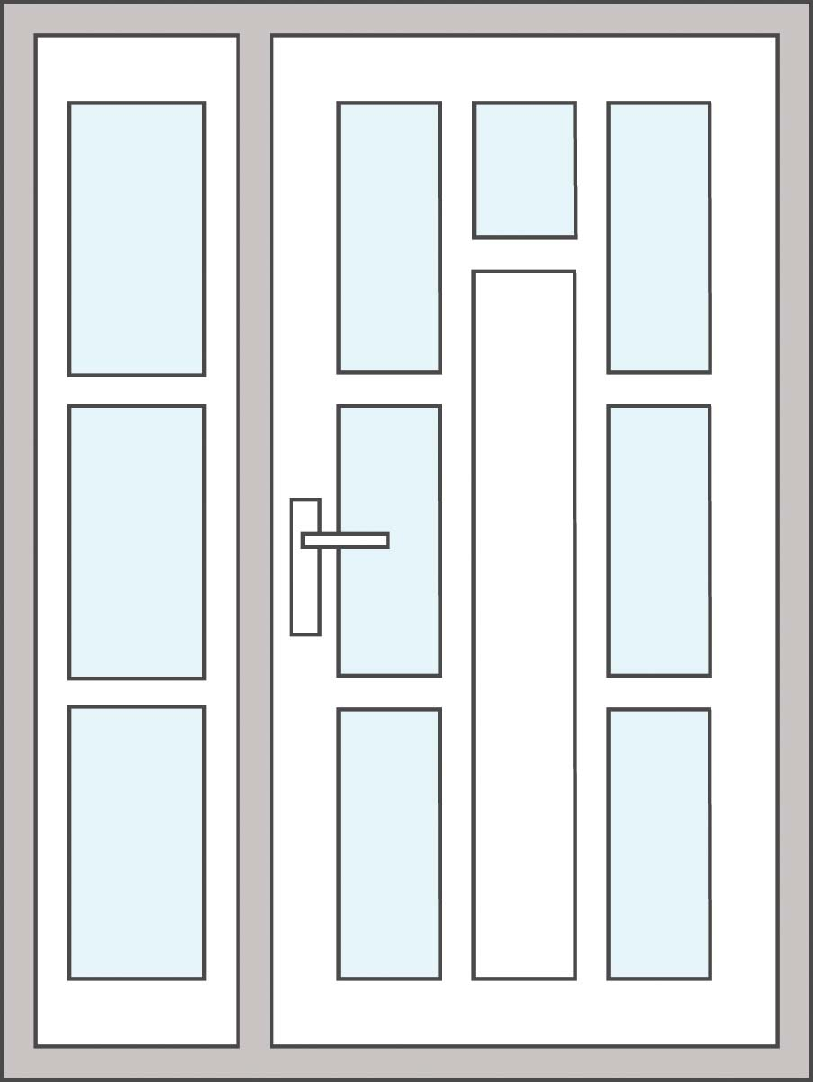](http://www.optimedia.com.ro/wp-content/uploads/2014/11/35.jpg)

**UȘA 19**

[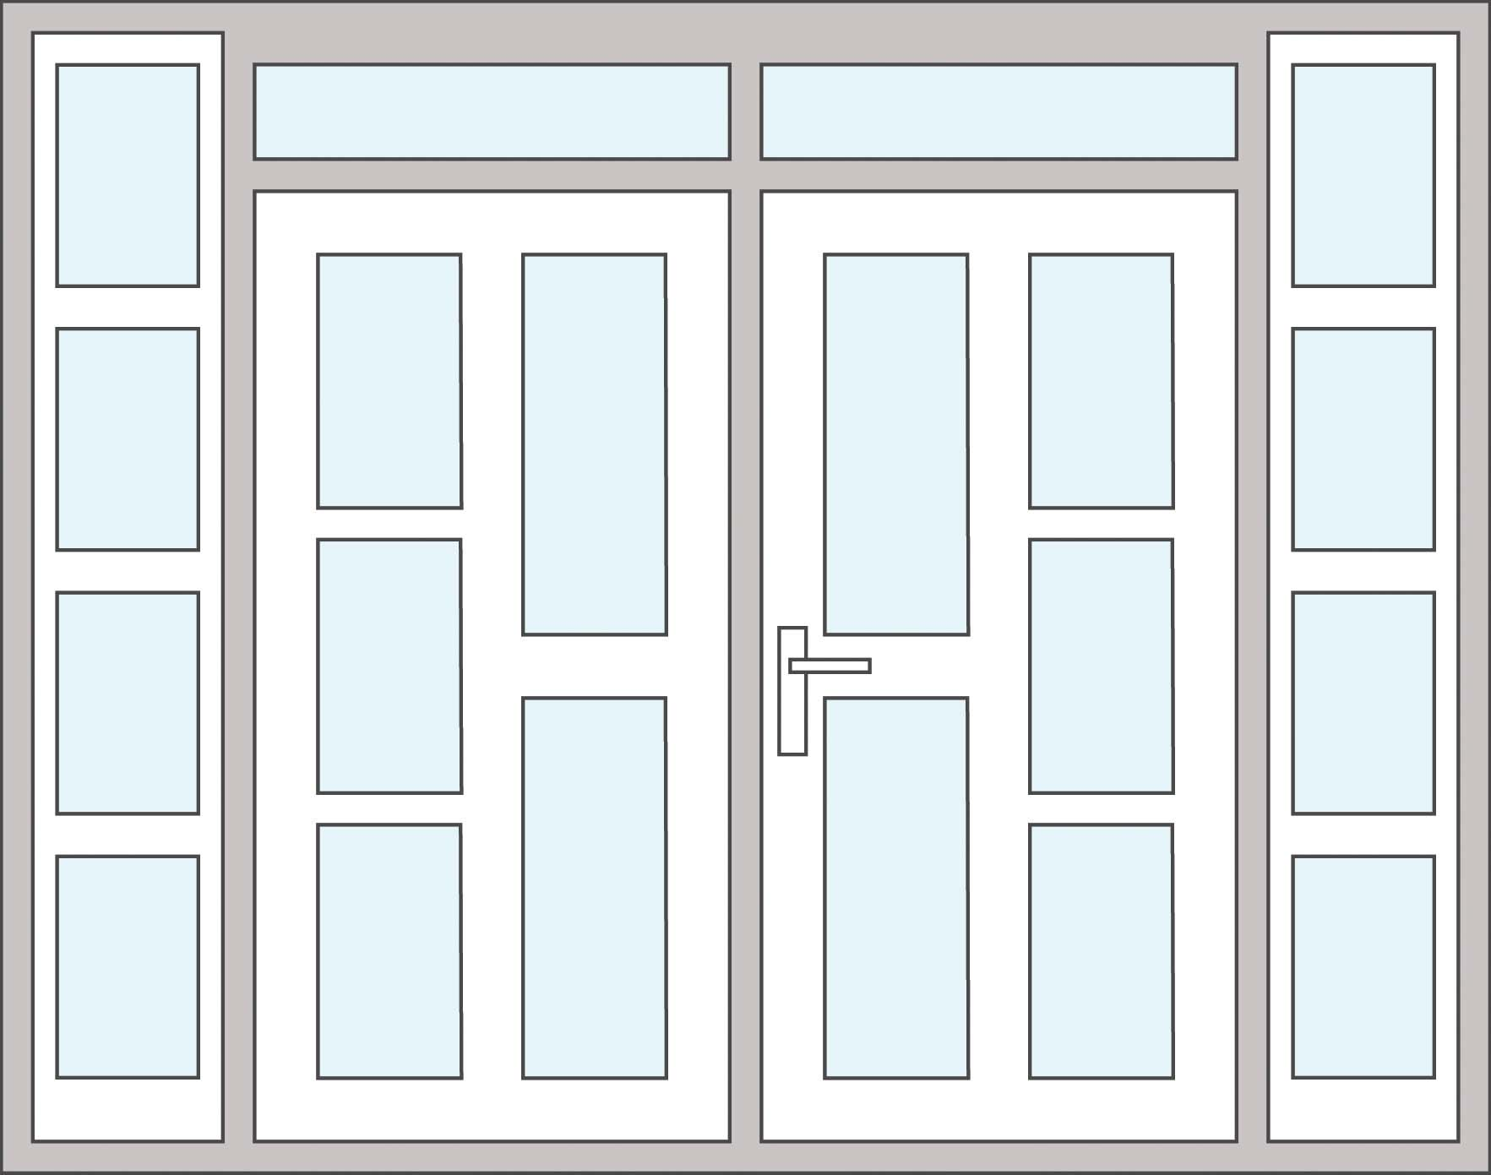](http://www.optimedia.com.ro/wp-content/uploads/2014/11/511.jpg)