

WNS 16g / 1.6mm ROLLFORMER

Principally used for joining sheet metal at right angles on straight runs, the machine comes with PITTSBURGH LOCK ROLLS.
Auxiliary shafts are fitted as standard, onto which other rolls such as DOUBLE SEAM ROLLs can be fitted
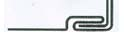
PITTSBURGH LOCK CLOSED PITTSBURGH LOCK
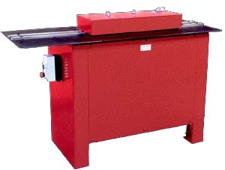
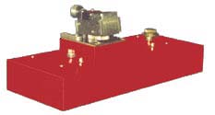
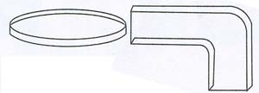
A Flanging Attachment can be fitted for forming right angle flanges on curved, straight and irregular shapes. It is fitted with a tilting head for forming complete circles

PITTSBURGH DRIVE DOUBLE PLAIN RIGHT STANDING
Auxiliary Rolls (STANDARD ) CLEAT* SEAM* SEAM* ANGLE* SEAM*
 |  | 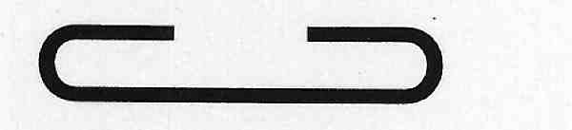 | 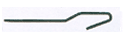 |  | 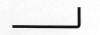 | 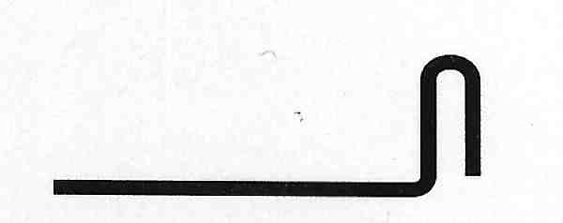
Material Used | 32mm | 54mm | 32mm | 11.0mm | 11.0mm | 54.0mm
Max. Thickness | 1.6mm | 1.0mm | 1.2mm | 1.0mm | 1.2mm | 1.2mm
Seam Width | 13mm | 29mm | 13mm | 10.0mm | - | -
Flange Height | - | - | - | - | 11.0mm | -
Seam Height | - | - | - | - | - | 19.0mm
* Optional
SPECIFICATIONS
LENGTH | WIDTH | HEIGHT | WEIGHT | MOTOR
1455mm | 615mm | 1000mm | Approx. 250kg | 2HP (1.5kw)
All capacities listed are based on the use of Rollforming quality mild steel.
We reserved the right to alter any specifications. All dimensions and weights are approximate

