DIRECT DRIVE MECHANICAL SHEAR

The Direct Drive Mechanical Shear is capable of shearing a wide range of materials accurately and consistently. Manufactured of a robust welded frame and fitted with heavy duty brake motor ensures maximum productivity and reliability. The DD mechanical shear is provided with a manual ‘Quickset’ for blade gap adjustment when changing from one job to another. Standard equipment includes one metre squaring arm complete with flip over stop, two one metre support arms complete with disappearing stops, rack and pinion, back stop, four edged blades, shrouded wander pedal, rear guarding with power cut off switch and clear view front finger guarding.

Caracteristici tehnice
Grosime maximă de material OL 37 =3.2 mm
Lungime maximă de tăiere =2500mm
Unghiul de tăiere=1°.
Număr de lovituri/ min =47
Înălţimea mesei de tăiere=800mm
Puterea motorului de acţionare =7,5kW
Dimensions 3124 x 2210 x 1180 mm (L x W x H)
Sistem de limitare la cotă cu traversă mobilă şi roată de manevră cu pinion
Gama de reglaj a sistemului de limitare din spate este de la 0 la 650mm
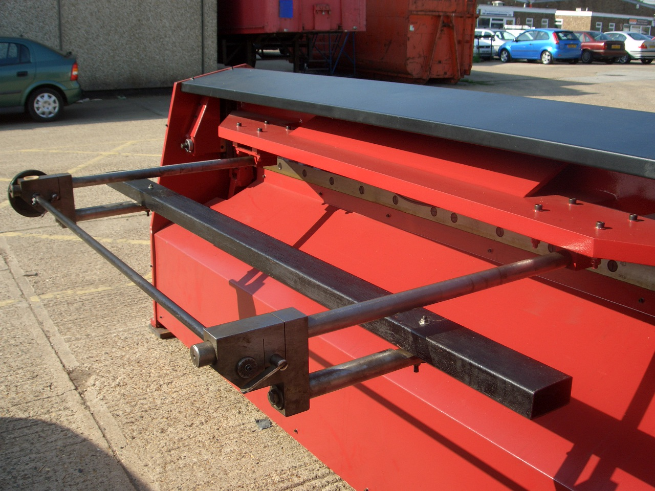
Ghilotina este dotată cu sistem de protecţie la spate cu plasă de sîrmă
** Optional; Sistem de limitare la cotă motorizat

