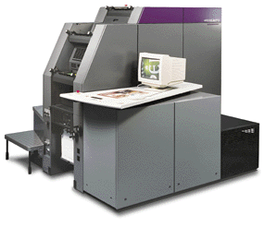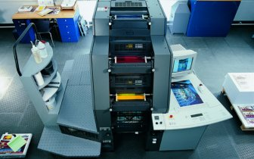
http://www.dipresses.com/newpage1.htm
Quickmaster DI 46-4
Technical specifications
Formats
Max. sheet format: 460 mm x 340 mm (18 1/8" x 13 3/8")
Min. sheet format: 140 mm x 89 mm (5 1/2" x 3 1/2")
Largest printable area: 450 x 330 mm (17 3/4" x 13")
Gripper margin: 10 mm (13/32")
Stock thickness: 0.06 to 0.30 mm (0.0016" to 0.012")
Direct Imaging
Imaging resolutions: 2,540 dpi
Imaging times: < 8 min. at 1,270 dpi
Laser diodes per printing unit: 8
Printing Plates
Presstek PEARL dry, multilayer masters for thermal imaging on supply reel, polyester base material.
No. of masters per reel: app. 35
Blanket cylinders
Length x width, metal edged: 555 mm x 337 mm
(21 7/8" x 13 1/4")
Thickness: 1.95 mm (0.077")
Blanket cylinder undercut: 2.3 mm (0.091")
Inking unit
No. rollers: 8 (incl. fountain roller)
Form rollers: 3
Diameter of form rollers: 54.7 - 45 - 50 mm
(2 1/8" - 1 3/4" - 2")
Pile heights
Feeder: 490 mm (2'7 1/4´´)
Delivery: 450 mm (1'5 3/4")
Connection power
Power consumption (at 50/60 Hz): approx. 10.5kW
About the press
Dimensions (length x width x height):
245 x 255 x 190 cm
(8' 1/2" x 8' 4 1/2" x 6'3 1/2")
Weight: 3,800 kg (8,378 lbs.)
Emission values: <80 dB (A)
Raster Image Processor
Hardware
High-performance IBM Intel workstation
Software
Delta Technology (optional: Harlequin ScriptWorks)

http://www.merrickind.com/MPC/Heidelberg.HTM

Specifications:
- Direct Imaging of the four printing plates with 64 laser diodes
- Simultaneous plate registration in six minutes
- Sharp-edged screen dot
- Fully automatic print preparation at the push of a button
- Automatic plate changing, cleaning, and blanket wash-up
- Waterless offset printing
- CP Tronic digital press control
- Up to 10,000 sheets/hour production rate
- Standard production sheet size 12" x 18"
- PostScript Level 2 RIP for Macintosh and PC compatibility
- Harlequin Interpreter
- Digital AlphaStation 200 4/233
- 64 Bit-RISC architecture
- 64 MB RAM, 233 MHz cycled
- Operating System - Windows NT Server 4.0
- Network interface - Ethernet with TCP/IP and Appletalk
- Soft proof check of bitmap data in various image sizes on the server and on the printing press
___________________________________________________________

