LI L lLLEd
 | Solar LED Flashlight Instruction
Model | HFY series
Applicabiltiy | A. Apply to house or outdoor lighting.  B.Suitable for use of hunters, hikers and campers.  C.Apply to military, security and other emergency situations.
Specification | A.One solar panel;  B.Super white patch LED with high power;  C.Three batteries fully charged under bright sunlight for about 9-10 hours;  D. Max. working time: 7-9 hours;  E: Three Ni-MH 600mAh rechargeable batteries.
Picture | 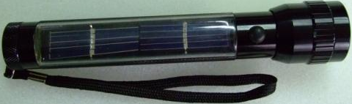
Feature | A: LED service life of up to 100,000 hours.  B: Suitable for less or no power regions.  C: compact appearance and portable character.
Package Size | Colorful box  Flashlight:  a: Inner carton: 4.0cm * 4.0cm * 19.8cm  b: Master carton: cm * cm * cm  c: Weight: kg  d. Volume: m3

1. A super white patch LED with high power.
2. Strong concentration of bright light, long service time.
3. Effective range of up to 100 meters, visible up to 1 km.
4. Max. working time: 4-6 hours.
5. Three Ni-MH 600mAh rechargeable battery.
6. High-efficient monocrystalline silicon solar panels.
7. Aluminum plating and alloy shell.
Features:
1. Just need solar light. Environmental protection and energy saving.
2. Compact appearance and portable character.
3. Suitable for less or no power regions.
4.LED service life of up to 100,000 hours.
Product size:
18.7cm*3.6cm

