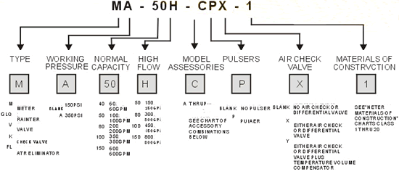
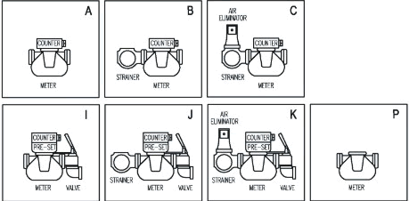
DEBITMETRE INDUSTRIALE LICHIDE USOR VISCOASE -NORMALE –CHIMIC AGRESIVE
Excellent stepless adjusting me chanism allows a micro adjustment of the meter
High accuracy and repeatability over the widest range of flow; Superior accuracy at constant flow
Low maintenance, no metal-to-metal contact in measuring chamber, long life service
Low pressure loss, a true gravity flow meter
Accuracy regardless of pressure fluctuations, temperature variation, viscosity
Choice of aluminum, cast iron and stainless steel materials of construction.
Industries
Automotive; Adhesives; Agriculture; Asphalt ; Aviation fueling ; Animal feeds; Beverage; Cosmetics ; Chemical processing; Concrete Add mixtures; Dairy; Liquid fertilizers; Food processing ; Fuel Oil delivery; General industrial; Hydrocarbon processing; Liquefied gases; Lube oils; Marine ; Paint and varnish ; Petroleum marketing ; Petroleum production ; Pharmaceutical; Printing ink; Pulp &paper; Refining commercial Solvents; Recycling ; Railroad ; Textile.

Application:
- Refined petroleum products;
- Aviation gasolines and jet fuels;
- A wide variety of products such as: liquid sugars, corn syrup, corn sweetners, dextrose, fructose, sucrose, maltose, lactose, corn oil, soy bean oil, cotton seed oil, coconut oil,.
- Treated waters (deionized, demineralized, and potable);
- Chlorinated solvents and general solvent metering;
- Acid pH liquids;
- Liquefied petroleum gas(LPG);
- Crude oil, also for heated and/or viscous liquids;
- Oil or water based latex products, polyester resins, and adhesives (neutral pH), also for metering herbicides and nitrogen fertilizer solutions;
- Herbicide;
- Sodium hydroxide (caustic) solutions, high sulfur crude oil (LACT and NOD) and other alkaline pH liquids
- Abrasive liquids

Model | IM-40 | IM-50 | IM-50 | IM-80 | IM-80 | IM-100 | IM-100H | IM-150 | IM-150
Size | 40mm / 1" | 50mm / 2 " |  | 80mm / 3 " |  | 100mm / 4 " |  | 150mm / 6 "and 100mm / 4 " for option
Flow Range (L/min) | 25-250 | 38-380 | 55-550 | 75-750 | 115-1500 | 130-1300 | 170-1700 | 225-2500 | 300-3000
Volume Per Revolution | 0.309L | 0.681L |  | 1.839L |  | 5.102L |  | 9.507L
Max.Pressure | +-0.2%
Accuracy | +-0.2%
Repeatability | +-0.05%
Standard  Measurement | LITER / US Gallon /IMP Gallon

Model | IM-40 | IM-50 | IM-80 | IM-100 | IM-150
Dimension | 53¡Á48¡Á53mm | 53¡Á48¡Á53mm | 58¡Á50¡Á61mm | 76¡Á64¡Á72mm | 80¡Á65¡Á79mm
Net Weight | 23kg | 26kg | 40kg | 70kg | 130kg
Gross eight | 35kg | 38kg | 55kg | 90kg | 155kg
Package | 1pc/Wooden Case

