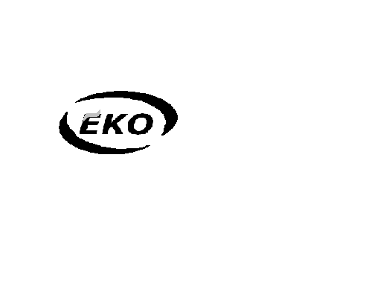
SC. EKO PRODUCTION & DISTRIBUTION S.R.L.
Bucuresti
Cod |  | Denumire | Pret (Lei)
HNN1 5060N |  | Hartie igienica, fara(N) tub, Negofrata, 1 strat, 50 buc x 60 grame - culoare Natur | 9.5
HNN1 7570N |  | Hartie igienica, fara(N) tub, Negofrata, 1 strat, 75 buc x 70 grame - culoare Natur | 15
HNG1 5060N |  | Hartie igienica, fara(N) tub, Gofrata, 1 strat, 50 buc x 60 grame - culoare Natur | 11.5
HNG1 5070N |  | Hartie igienica, fara(N) tub, Gofrata, 1 strat, 50 buc x 70 grame - culoare Natur | 12
HNG1 5090N |  | Hartie igienica, fara(N) tub, Gofrata, 1 strat, 50 buc x 90 grame - culoare Natur | 15
HNG1 5090N |  | Hartie igienica, fara(N) tub, Gofrata, 1 strat, 45 buc x 100 grame - culoare Natur | 15
HTG1 5060N |  | Hartie igienica, cu Tub, Gofrata, 1 strat, 50+10 buc x 60 grame - culoare Natur | 12
HTG1 5060R |  | Hartie igienica, cu Tub, Gofrata, 1 strat, 50+10 buc x 60 grame - culoare Roz | 13.5
SNP 1010 |  | Servetele nazale, Parfumate, 10 pachete (bax) | 2
 |  | La 10 bax-uri de hartie comandata se ofera un bax gratuit.
Contact:
 |  | Victor Iliescu – Tel : 0722.730.341
 |  | Depozit - Tel : 021.310.32.59

