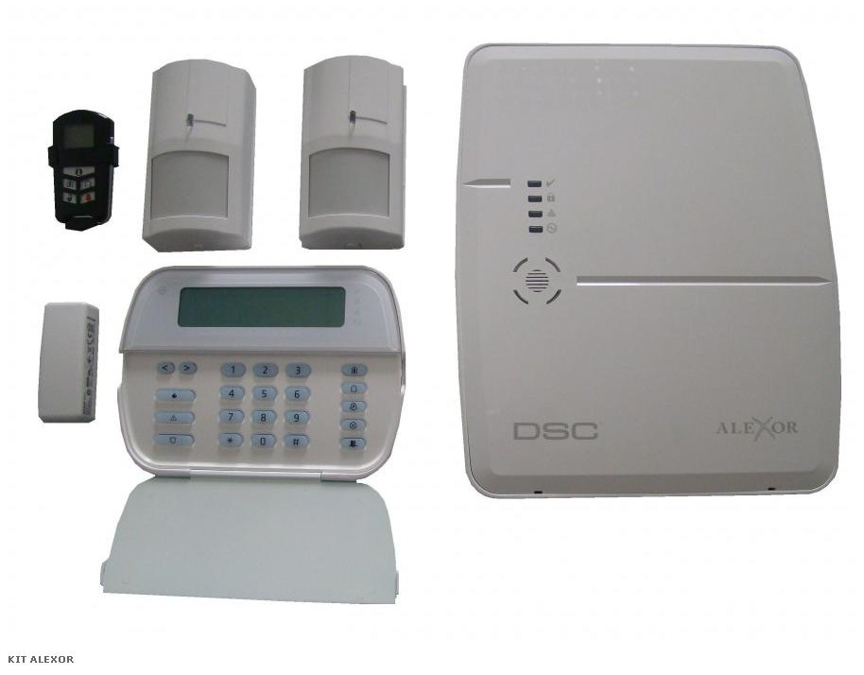

Kit format din centrala ALEXOR x 1, tastatura WT5500 x 1, detectori WLS904 x 2, telecomanda LCD x 1, contact magnetic WLS4945 x 1, inclus acumulator si transformator