OFERTA PRET “IL JOKER SHOW”

DANSATOARE ORIENTAL - 100 RON / 2 DANSURI

ILUZIONIST - 350 RON / 30 MIN

DANSATORI FOC -350 RON/ DANS

FACHIR - 150 RON / PROGRAM

CLOWN PE CATALIGE - 120 RON /h

CLOWN MONOCICLA - 100 RON/ h

CLOWN ANIMATOR – 100 RON/h (170 ron cu face painting si baloane modelate incluse in pret)

DJ - DISCUTABIL

MICHAEL JACKSON -100 RON/ DANS 5MIN.

ARANJAMENTE BALOANE CELE MAI MICI PETURI

PACHET 1:DISCOUNT

DANSATOARE ORIENTAL
ILUZIONIST
DANSATORI FOC 800 RON/ PROGRAM 60 MIN.
FACHIR
CLOWN CATALIGE

PACHET 2 : DISCOUNT

DANSATORI FOC
ILUZIONIST 600 RON/PROGRAM 45 MIN.
FACHIR
MICHAEL JACKSON

tel. 0729 50 82 40 sau 0726 58 99 58
e-mail: iljokershow@gmail.com
www.iljokershow.blogspot.com
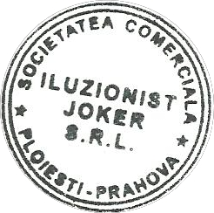
search youtube: il joker show preturile nu includ TVA

