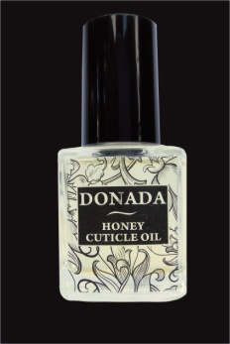 Ulei pentru cuticule cu miere
Regenereaza , mentine unghiile si cuticulele elastice datorita uleiului de jojoba,vitamina E, bisabol ,extract de polen si propolis.Accelereaza cresterea unghiilor.
15ml
Mod de folosire:Se aplica pe cuticula 2-3 pe zi.
Състав по INCI: Cyclomethicone, Hexamethyldisiloxane, Propylheptyl Caprylate, Isopropyl Myristate, Ethoxydiglycol, Buxus Chinensis Oil, Parfum, Tocopheryl Acetate, Bisabolol, Bee Pollen, Propolis, Limonene.

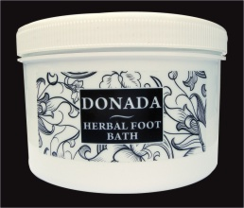 SARE PENTRU PEDICHIURA
Curata dezinfecteaza si accelereaza procesul de inmuiere .
500gr
1000gr
Състав по INCI: Urea, Alcohol Denat., Sodium Hexametaphosphate, Trisodium Phosphate, Sodium carbonate, Sodium Aluminosilicate, MIPA - Laureth Sulfate, Laureth–4, Cocamide DEA, Sodium Bicarbonate, Kalanhoe Pinnata, Sodium Borate, Mentha Arvensis Oil, Lavandula Angustifolia Oil, Menthol, Eucalyptus Globulus Oil, Camphor, Glycerin, Aqua, Phenethyl Alcohol, PPG-2-Methyl Ether, Methylisothiazoline, Methyl Salicylate, CI 61570, CI 47005, Linalool, Limonene.

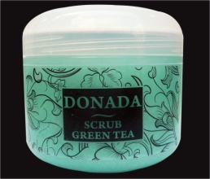scrub green tea/scrub ceai verde pentru maini si corp
.Combinatia de zahar ,sare si ulei de sheya are effect multifunctional.Cristalele mari de zahar indeparteaza in prima faza straturile de cellule moarte,sarea fina incheie procesul de peeling.Uleiul de sheya ajuta la regenerarea pielii si are proprietati antioxidante.Continutul bogat in vitamina E catifeleaza si netezeste pielea.Se aplica pe pielea curatata cu miscari lente de masaj excesul se indeparteaza cu apa.
250ml

Състав по INCI: Aqua, Propylheptyl Caprylate, Aloe Barbadensis, Propylene Glycol, Aluminium Starch Octenyl Succinate, Isopropyl Myristate, Cyclomethicone, Alcohol Denat., Cyclopentasiloxane, Dimethiconol, Isopropyl Palmitate, Pentaerythrityl Distearate, Glycerin, Glyceryl Stearate, PEG-100 Stearate, Cetearyl Alcohol, Sodium Polyacrylate, Sodium Stearoyl Glutamate, Parfum, Phenoxyethanol, Methylparaben, Ethylparaben, Propylparaben, Butylparaben, Limonene, Linalool, Citral, Hexyl Cinnamal, Geraniol, Citronellol, CI 19140, CI 42051.

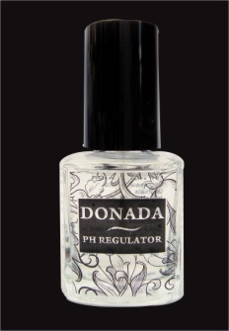ph REGULATOR. Degreseaza placa unghiala.Se aplica direct pe unghie inaintea procedeelor de lac sau gel
15ml
Състав по INCI: Ethyl Acetate, Isopropyl Alcohol, Ammonium Hydroxide.

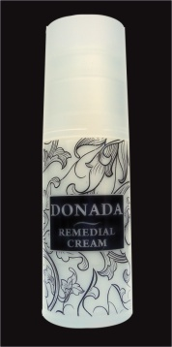remedial cream
Indicata pentru calcaiele crapate si bataturi .Se aplica de 2 ori pe zi .Regenereaza
60ml

Състав по INCI: Aqua, Urea, Dicocoyl Pentaerythrityl Distearyl Citrate, Sorbitan Sesquioleate, Cera Alba, Aluminum Stearates, Lanolin, Petrolatum, Glycerin, Isopropyl Myristate, PEG -7 Hydrogenated Castor Oil, Paraffinum Liquidum, Ethylhexyl Stearate, Ozokerit, Ethoxydiglycol, Octyldodecanol, Dimethicone, Magnesium Sulfate, Allantoin, Parfum, Phenoxyethanol, Methylparaben, Ethylparaben, Propylparaben, Buthylparaben, Lactic Acid, Glycolic Acid, Citric Acid, Malic Acid, Salicylic Acid, Cumarin, Benzyl Salicylate, Benzyl Benzoate, Eugenol, Hexyl Cinnamal, Butylphenyl Methylpropional, Limonene, Linalool, Hydroxyisohexyl 3-Cyclohexene Carboxaldehyde, Alpha-Isomethyl Ionone.
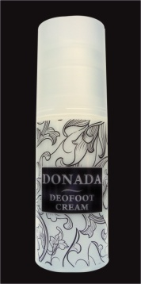deofoot cream
24h intensive .Actioneaza 25h impotriva mirosului neplacut si al ciupercilor.
60ml
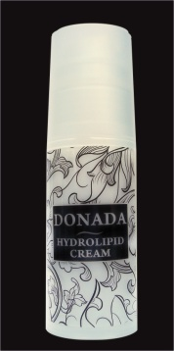produs ce ajuta la restabilirea proceselor de regenerare.Urea in combinatie cu glicerina ajuta la eliminarea batatturilor.Folosirea regulate garanteaza indepartarea mirosului neplacut,leziunilor si a ciupercilor
60ml

Състав по INCI: Aqua, Glyceryl Stearate, Ceteareth-20, Ceteareth-12, Cetearyl Alcohol, Cetyl Palmitate, Urea, Glycerin, Cyclomethicone, Isopropyl Palmitate, Alcohol Denat., Dimethicone, Steareth - 21, Bisabolol, Parfum, Penoxyethanol, Methylparaben, Ethylparaben, Propylparaben, Butylparaben, Benzyl Salicylate, Hexyl Cinnamal, Butylphenyl Methylpropional, Limonene, Linalool.
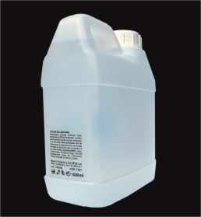polish remover/dizolvant fara acetone
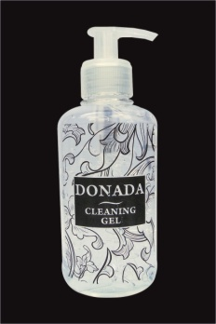
gel dezinfectant.Curata si dezinfecteaza fara a usca pielea
250ml
30ml
Състав по INCI: Alcohol denat., Aqua, Glycerin, Acrylates/C₁₀₋₃₀ Alkyl Acrylate Crosspolymer, Parfum, Menthol, Tetrahydroxypropyl Ethylenediamine, Limonene.

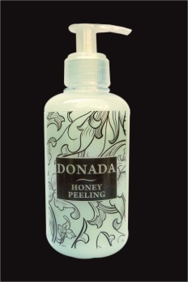 МЕДЕН СКРАБ
SCRUB CU MIERE curata celulele moarte fara a usca sau irita pielea .Mod de folosire:Se aplica cu miscari de masaj pe pilelea curate
250ml
Състав по INCI: Aqua, Alcohol denat., Nilon 12, Propylene Glycol, Cyclomethicone, Mel, Glycerin, Bee Pollen, Sodium Polyacrylate, Octyldodecanol, Tetrahydroxypropyl Ethylenediamine, Acrylates /C10-30 Alkyl Acrylate Crosspolymer, Parfum, Penoxyethanol , Methylparaben, Ethylparaben, Propylparaben, Buthylparaben.

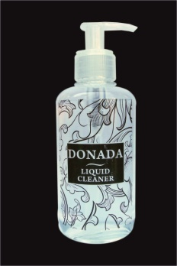Lotiune pentru servetelele presate cu trandafir .Nu usuca pielea.
250ml
1000ml
Състав по INCI: Aqua, Alcohol denat., Nilon 12, Propylene Glycol, Cyclomethicone, Mel, Glycerin, Bee Pollen, Sodium Polyacrylate, Octyldodecanol, Tetrahydroxypropyl Ethylenediamine, Acrylates /C10-30 Alkyl Acrylate Crosspolymer, Parfum, Penoxyethanol , Methylparaben, Ethylparaben, Propylparaben, Buthylparaben.

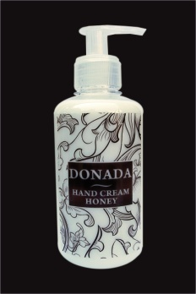 Crema pentru masaj regeneratoare
Contine emolienti cu o mare putere de penetrare.Regenereaza si hraneste in adancime pielea.Imbunatateste aspectul pielii cu ajutorul componentelor biologic active-miere de albine si extract de pollen.Mod de folosire:Aplicati o pompa pe mainile curatate in prealabil si masati 90 de secunde pentru fiecare mana.
250ml
Състав по INCI: Aqua, Isopropyl Palmitate, Glycerin, Isopropyl Myristate, Lanolin, Cyclomethicone, Glyceryl Stearate, PEG-100 Stearate, Dimethicone, Glyceryl Stearate SE, Aluminium Starch Octenyl Succinate, Cyclopentasiloxane, Dimethiconol, Cetearyl Alcohol, Mel, Ceteareth - 20, Bee Pollen, Parfum, Tetrahydroxypropyl Ethylenediamine, Alcohol denat., Bee Pollen,
Acrylates /C₁₀₋₃₀ Alkyl Acrylate Crosspolymer, Phenoxyethanol, Methylparaben, Ethylparaben, Propylparaben, Butylparaben.
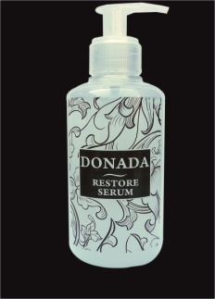 SER HIDRATANT
Hidrateaza si regenereaza pilea datorita formulei Aquaxyl® si aloe vera.Mod de folosire:Se aplica pe pielea curata cu miscari de masaj dupa care mainile se baga in manusile Termo.
250ml
Състав по INCI: Aqua, Glycerin, Propylene Glycol, Xylitylglucoside, Anhydroxylitol, Xylitol, Sodium Polyacrylate, Sodium hyaluronate, Aloe Barbadensis, Allantoin, Phenethyl Alcohol, PPG-2-Methyl Ether, Methylisothiazoline Lactic Acid, Glycolic Acid, Citric Acid, Malic Acid, Salicylic Acid.

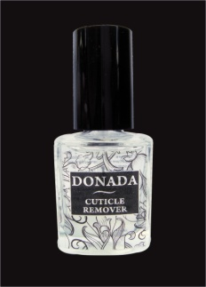 Gel pentru cuticula.
Indeparteaza cuticula.Mod de folosire:Se aplica pe cuticula dupa care se indeparteaza imediat cu spatula .Dupa terminarea procedurii se indeparteaza cu un servetel umed.
15ml
Състав по INCI: Aqua, Glycerin, Potassium Hydroxide, Hydroxyethylcellulose.

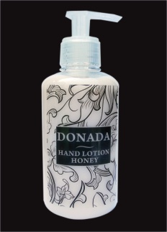 LOTIUNE CU MIERE imbunatateste procesul de regenerare si asigura elasticitatea perfecta pielii datorita componentelor active de miere de albine si extract de polen.Untul de shea si alte ingrediente rapid absorbate de piele asigura un strat de protectie impotriva mediului extern.Mod de folosire:Se aplica pe pielea curatata in prealabil cu miscari de masaj.
30ml
250ml
Състав по INCI: Aqua, Alcohol denat., Butyrospermum Parkii (Shea Butter), Isopropyl Palmitate, Propylheptyl Caprylate, Ethylhexyl Stearate, Cetearyl Alcohol, Steareth-21, Propylene Glycol, Glyceryl Stearate, PEG-100 Stearate, Mel, Glycerin, Bee Pollen, Dimethicone, Tetrahydroxypropyl Ethylenediamine, Acrylates / C₁₀₋₃₀ Alkyl Acrylate Crosspolymer, Parfum, Penoxyethanol, Methylparaben, Ethylparaben, Propylparaben, Buthylparaben, CI 15985.
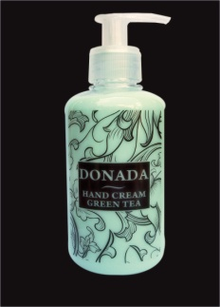crema cu ceai verde
Asigura hidratarea perfecta mainilor datorita procentului ridicat de Aloe Vera,glicoli si uleiuri esentiale.Penetreaza rapid lasand mainile catifelate.Se aplica pe mainile curatate si uscate in prealabil .
250ml
30ml
Състав по INCI: Aqua, Propylheptyl Caprylate, Aloe Barbadensis, Propylene Glycol, Aluminium Starch Octenyl Succinate, Isopropyl Myristate, Cyclomethicone, Alcohol Denat., Cyclopentasiloxane, Dimethiconol, Isopropyl Palmitate, Pentaerythrityl Distearate, Glycerin, Glyceryl Stearate, PEG-100 Stearate, Cetearyl Alcohol, Sodium Polyacrylate, Sodium Stearoyl Glutamate, Parfum, Phenoxyethanol, Methylparaben, Ethylparaben, Propylparaben, Butylparaben, Limonene, Linalool, Citral, Hexyl Cinnamal, Geraniol, Citronellol, CI 19140, CI 42051.
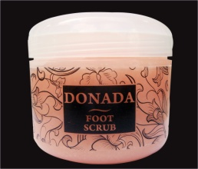scrub pentru pedichiura
Combinatia de zahar cu sare de mare indeparteaza celulele moarte.Hidratarea este asigurata de uleiurile esentiale imbunatatind astfel aspectul pielii.MOD DE FOLOSIRE:Aplicati o cantitate mica pe picioare si masati.
250ml
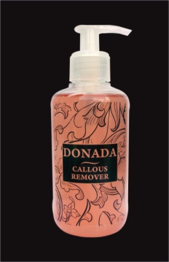gel pentru calozitati
Ideparteaza depunerile din zona calcaielor si bataturile.Aplicati pe un pad o cantitate mica de gel si acoperiti zonele cu probleme,infasurati picioarele in folie de plastic si lasati sa actioneze 10-15 minute dupa care indepartati cu o spatula ,la final clatiti din abundenta si aplicati” balance foot cream “
250ml
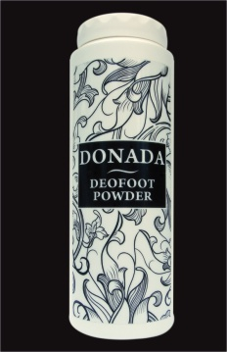deofoot powder/pudra pentru picioare
Previne aparitia mirosului neplacut si micozelor.Ingredientele active absorb umiditatea si previn aparitia mirosului neplacut.Aplicati direct pe picioare ,in sosete sau pantofi.
100gr
Състав по INCI: Talc, Zinc Oxide, Calcium carbonate, Aluminium Starch Octenyl Succinate, Alcohol Denat., Capryloyl Glycin, Undecylenoyl Glycin, Menthol, Camphor, Parfum, Propolis, Penoxyethanol, Methylparaben, Ethylparaben, Propylparaben, Buthylparaben, Benzyl Salicylate, Hexyl Cinnamal, Butylphenyl Methylpropional, Limonene, Linalool.
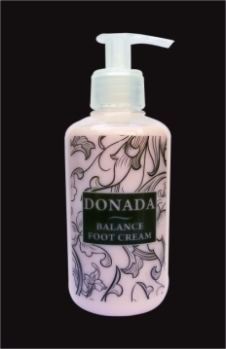balance foot cream /crema hidratanta pentru picioare
Contine extract de Aloe Vera si Sheya ce asigura o hidratare in profunzime imbunatatind aspectul pielii .Se aplica pe pielea curatata in prealabil dupa procedura cu CALLOUS REMOVER
250ML

