S.C. A&G Optik Service Group SRL
Mihai Olteanu
Tel: 0737.214.274

RAME PLASTIC
Tip | Pret (lei)
KAMUS | 94
SAFEGUARD, VICTORY, SONE, GOOD LUKE, FAVORIT, VOLANT, LAS VEGAS, ENNI MARCO, OLIMPIC, CHARM, BLACK ROSE | 96
KIND, J.P., MORGAN, GOOD LUCK, RENATO, GOLD BUG, AGATE, DAFIDGE | 97
CAILI (pl + metal), VEBA | 99
TRIUMPHAL ARCH, GUIDE, KIND flex, CAMERLY, SWEET ALICE | 101
ASTOR, REAL, EDOX, MODERN LADY citit, ATTICA, ALAINE, C.C.DK | 102
SONE cu metal, REAL | 103
CACIOBOS | 105
ARISTOCRAT | 106
SUNTA, OMG | 108
MODERN LADY, ECLIPSE | 110
ESTER LAUREL | 115
STRIKE | 116
GOOD LUCK | 120
HUGO CONTI strasuri | 112
HUGO CONTI | 122
GOOD LUCK brat metal | 128
VERTEX, ROMEO | 135
CONSUL, ELIZA | 145
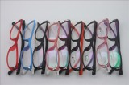

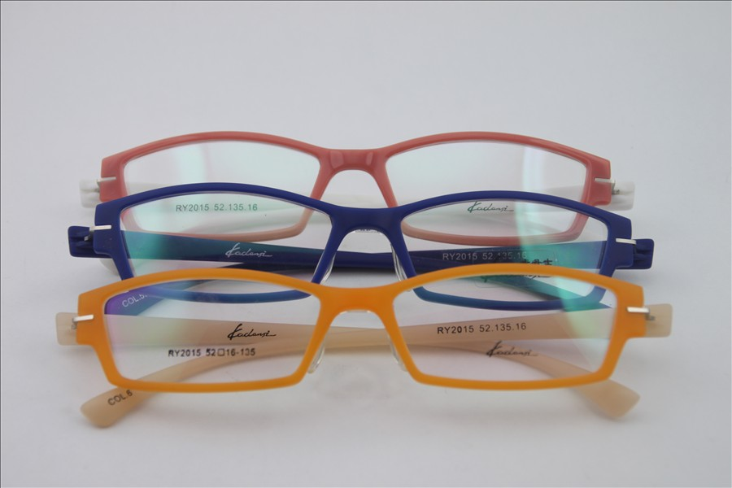

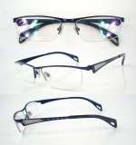
RAME METAL
Tip | Pret (lei)
MIEN, AERODVOSE, KAMUS, AIOLA, RAFAELLO, BARTON | 97
COPIL - brat arc, POKEMON, HAPPY, COPIL children world, children land | 99,5
BROTHER, MIEN cu sa, RAFAELLO cu sa | 98
RED APPLE, KK, ROBEN, ISI, LONDON rotund | 99
HARLEY, DALI, ESLEK, BLUE EYE, BLACK ROSE, VENETIA, ARISTOCRAT | 100
CHARM, GOLF, CAESAR, LOZZA, VEBA, BERKINDON | 101
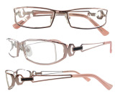  RICH PERSON, GUIDE, POP, HUDIE, AUMAN, ROTCHILD, BLUE LIGHT, TR ARCH, D.S.F. | 102
CAILI, HOPE, ENI MARCO, NEW FASHION, SONE, SOLO, GALA, GOLD BUG, CHARM cu sa | 103
NORTH BEAR, FEALI | 104
OLEISS, ROLAND, NEW FASHION | 105
HR, HUGO CONTI | 106
MATASA, OLIMPIC, FERET | 107
KIND, ALAINE, MILD SEVEN, GOLDEN LION, JULIEN, BADEN EDE, ROSSI, YAMMA | 108
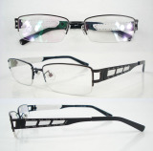  NIKPHOROS, VANESSA, SOLO | 99
WINER, KIND brat titan, KING BEAR | 101
BLUE SHARK, PREFFER, DUBEN, CENTURE SUNSHINE, X.C. | 102
SWEET LIFE, SOILTE | 103
LEDIX, MODERN LADY, MAGICEAGALKING, CONSUL, SUNSHINE BROTHER, CAILI | 105
ECLIPSE, LAGUNA, ASTOR, POPULAR | 107
ELEGANCE, RENATO, CARDYDANY | 109
SHOOR, LANGKEY, PAULO ROSSI, ESTEE DANIE, ACCELERATION | 111
DIXON, L.V.S. | 112
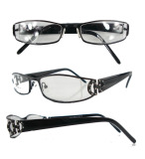  STATUE OF LIBERTY, FEALI | 118
ROSOIANA, ROMEO, VERTEX, COUNTRY, DIVERONA, SANTIAN, ANTONIO VIVALDI | 125
GROSSO 1/2 | 122/133
VIVA, ROMEO | 135
SHOOR, ELIZA | 140
SUCCESSFUL PERSON | 165

RAME CU FIR
Tip | Pret (lei)
MIEN, RAFAELLO | 98
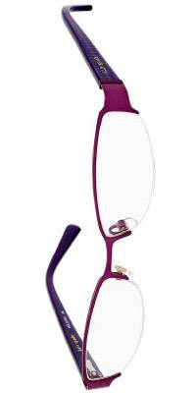  COPIL PIXIE | 100
CHARM | 101
TRIUMPHAL ARTS | 102
ENI MARCO, CAILI, SOLO | 103
OLEISS, FEALI, NEW FASHION, FAVORIT | 105
FERRET | 107
EDOX, KIND, GOLDEN LION, ALAINE | 108
VANESSA, SOLO, WECAFARE | 109
MATASA, MAIBELIN | 110
CENTURE SUNSHINE, XC, BLUE SHARK | 112
SOILTE | 113
ENIGMA, CONSUL, LEDIX | 115
ECLIPSE, LAGUNA, CURENCY | 117
RENATO, ELEGANCE, CARDYDONY | 119
ASTOR, LANG KAY, SHOOR, PAULO ROSSI, EEGER, LONDON | 120
ANTONIO VIVALDI, CLIP ON | 135
VIVA | 145
DAUM | 153

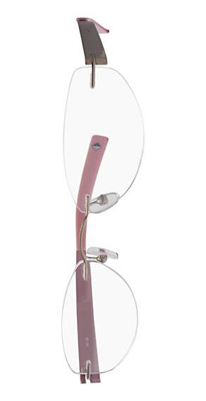
RAME CU SURUB
Tip | Pret (lei)
ENI MARCO | 93
NEW FASHION | 95
SILVESTER, FLALI, EDOX | 98
JULIEN | 100
SOILTE | 103
OLEISS, SOIVE | 104
RENATO | 109
MATASA, EEGER | 110

RAME TITAN
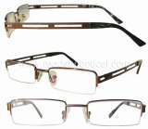  Tip | Pret (lei)
PIAGET brat flex / flex total | 105/110
MATASA, COPIL FLEX | 105
PARIL fir, LONDON fir, MATASA flex fir | 110
CHARMANT, RICH, TRENDY LINE | 110
TITAN fir - brat flex / flex total | 95/98
TITAN surub flex | 105


RAME TITAN 100%
Tip | Pret (lei)
ROYAL ROVER, ALAINE | 165
HUGO CONTI, SUCCESSFUL PERSON | 170
LICHADE | 175
DUBON ENYWER | 185
CAREPUER, DE ER HUI | 200

