Euroguard International Professional Services

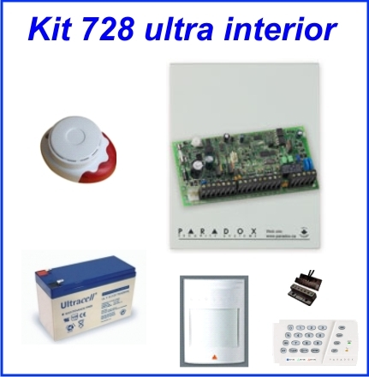
Kit 728 Int.: Centrala 728 ULT
Tastatura 636
Detector miscare PRO(476+)
Sirene interior
Contact moagnetic
Acumulator 12v/7Ah
Cutie metalica

Pret 560ron Tva inclus
Pret cu montaj 610ron Tva Inclus

----------------------------------------------------------------------------------------------------------------------------------------------------------------------------

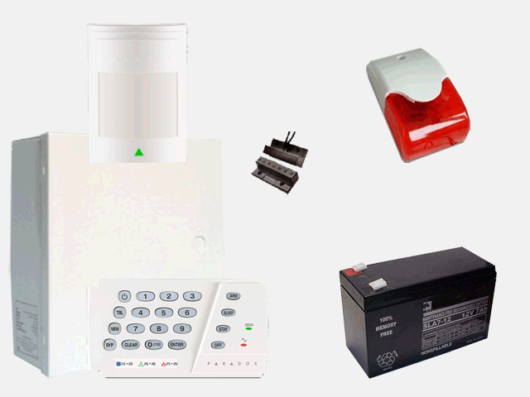
Kit SP4000 Int.: Centrala Sp4000
Tastatura K636
Detector miscare PRO(476+)
Sirene interior
Contact moagnetic
Acumulator 12v/7Ah
Cutie metalica

Pret 500ron Tva inclus
Pret cu montaj 650ron Tva Inclus

----------------------------------------------------------------------------------------------------------------------------------------------------------------------------

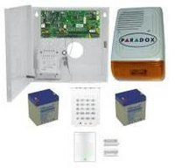
Kit SP4000 Int.: Centrala Sp4000
Tastatura K636
Detector miscare PRO(476+)
Sirene interior
Contact moagnetic
Acumulator 12v/7Ah
Cutie metalica

Pret 675ron Tva inclus
Pret cu montaj 825ron Tva Inclus

