

1.Model: Classic9 TAN

Military Spec Desert Tan
Full Grain Leather Toe
Steel Shank
1000 Denier Nylon & Leather Upper treated with 3M Scotchgard for stain; soil; and water repellancy
Compression Molded EVA Midsole
Outsole Stitched at Toe and Heel
Thermoplastic Heel & Toe Counters
Outsole meets ASTM F489-96 test standards for slip resistance
Aegis® Anti-Microbial Lining and Removable Orthotic Footbed provides protection against odor staining and deterioration caused by bacteria fungus and other microorganisms and is a permanently bonded antimicrobial barrier.
Electric Hazard Protection meets ASTM F2412-05 and ASTM F2413-05 EH Test Standards

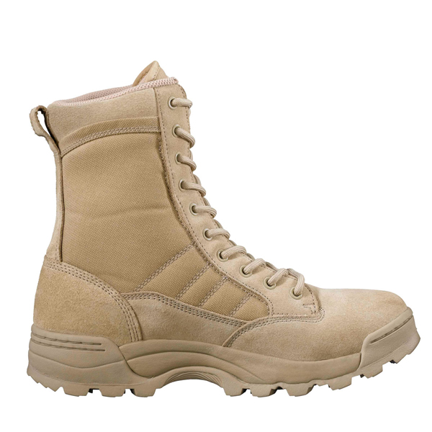
2.Model:SEK9000 ZIP
Full Grain Leather Upper
100% YKK® with Velcro® Closure
Proprietary High-Traction Self Cleaning Multi-Tread Carbon Rubber Outsole with Reinforced Arch
Aegis® Anti-Microbial Lining and Removable Orthotic Footbed provides protection against odor staining and deterioration caused by bacteria fungus and other microorganisms and is a permanently bonded antimicrobial barrier
Compression Molded EVA Midsole
Thermoplastic Heel & Toe Counters
Exclusive Original SWAT Tactical Last
Non-Fray Stay-Tie Tactical Laces
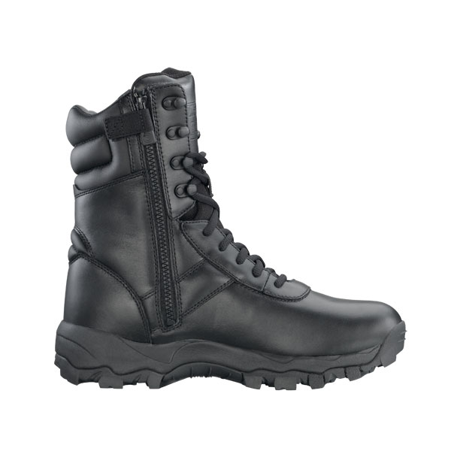

3.Model: Classic6
Full-Grain leather toe
Triple stitched upper with 3-Ply bonded nylon thread
Stitched outsole at toe & heel
Aegis® anti-microbial removable orthotic footbed
Slip resistant self-cleaning multi-tread carbon rubber outsole
Electric Hazard Protection - meets ASTM 2412-05 & ASTM 2413-05 EH test standards
Compression solded EVA sidsole
Riveted steel shank sandwiched between Texon® insole and reinforced shank board
Molded thermoplastic heel & toe counters

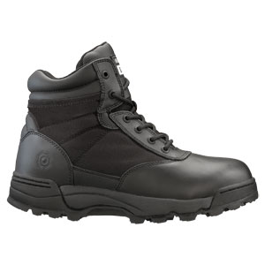

4.Model: Classic 9 Black

Full Grain Leather Toe
Steel Shank
1000 Denier Nylon & Leather Upper
Compression Molded EVA Midsole
Outsole Stitched at Toe and Heel
Thermoplastic Heel & Toe Counters
Outsole meets ASTM F489-96 test standards for slip resistance
Aegis® Anti-Microbial Lining and Removable Orthotic Footbed provides protection against odor staining and deterioration caused by bacteria fungus and other microorganisms and is a permanently bonded antimicrobial barrier.
Electric Hazard Protection meets ASTM F2412-05 and ASTM F2413-05 EH Test Standards

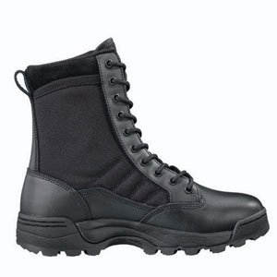
www.swatoriginal.ro

