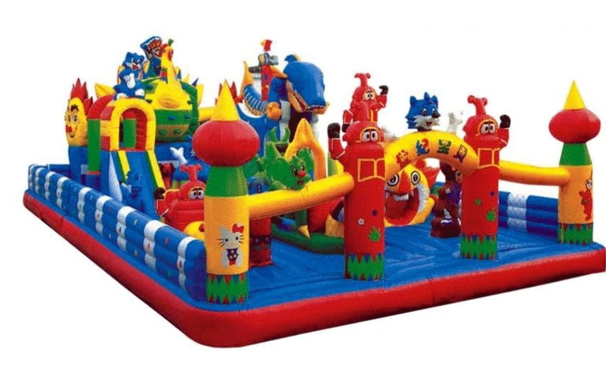

Complex de joaca gonflabil cu obstacole 1400/700/510cm pvc(tarpaulin) 0.5mmm,greutate bruta 441kg, cu turbosuflanta 220v,1100w cod ZY-04103 - pret 6000 eur