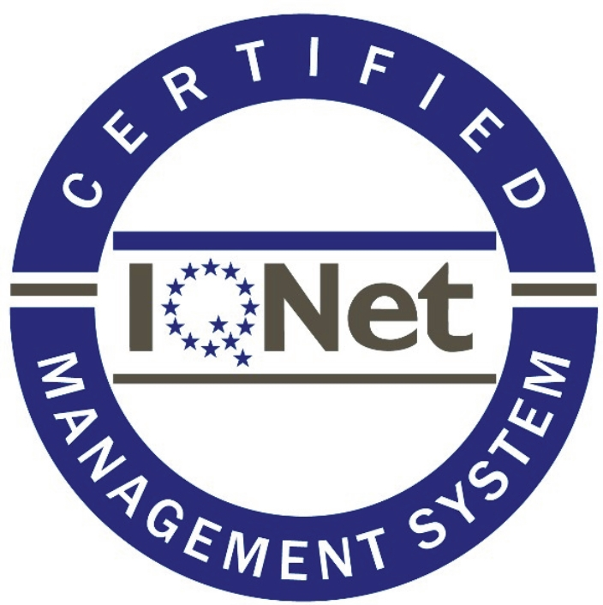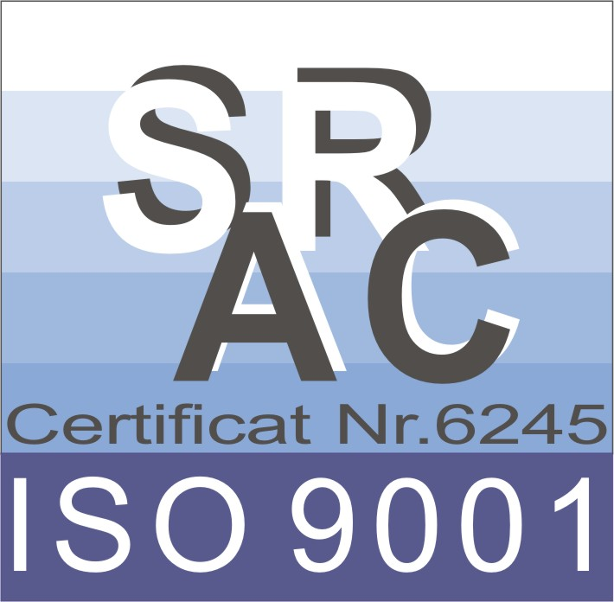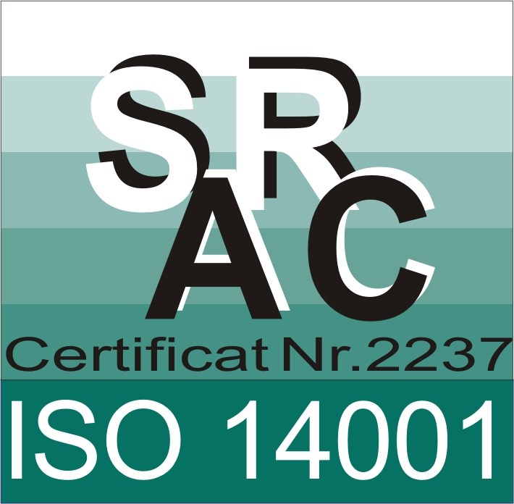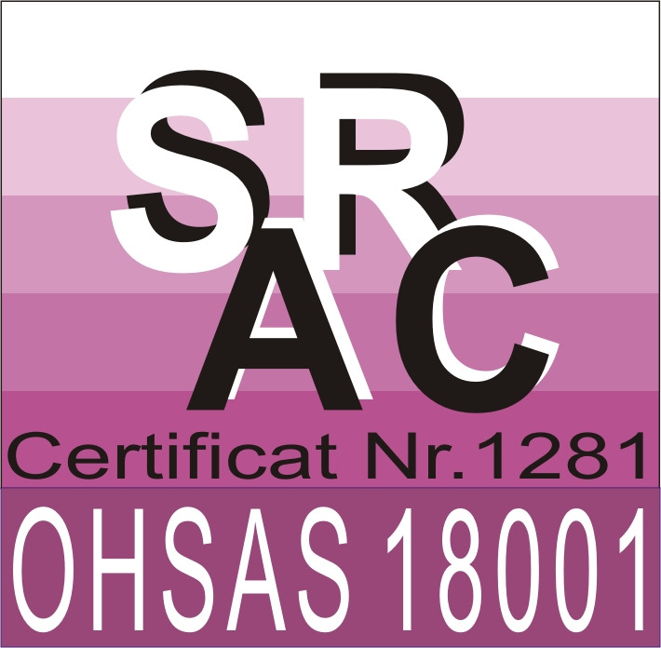
SC MODEST CONSTRUCTII SRL
TG.MUREŞ, 540 461, str. NEGOIULUI nr. 55. RO11731758 J/26-295 / 1999
TEL/FAX 0365 809 548 CONT RO92 RNCB 0188 0349 6984 0001
MOBIL 0742 557 214 E-mail:scmodestconstructiisrl@yahoo.com

